Pray for peace this Christmas – joint message from Wales’ Christian leaders

Christian leaders, representing churches and chapels across Wales, are joining together to invite people to pray for peace this Christmas.

The Anglican Archbishop of Wales, Andrew John, the Roman Catholic Archbishop of Cardiff and Bishop of Menevia, Mark O’Toole, and the Moderator of the Free Church Council of Wales, Simon Walkling, are issuing a joint message which acknowledges the tensions and tragedies in the world today and invites people to church to reflect and pray for peace.

The news has been full of the terrible tragedy unfolding in Gaza after the awful terrorist attack on Israel. Thousands of children killed in a war they did not choose. It seems a long way from the Christmas adverts here and the pressure to be merry. It is understandable that the church leaders in Jerusalem have invited Christians there to forego any unnecessarily festive activities and stand strong with those facing affliction. They see it as standing in support of those continuing to suffer, just as Jesus did by being born as a baby in Bethlehem two thousand years ago.

Jesus was born in a land occupied by the Romans. He was born away from home because of an imperial census. There were family tensions around Mary being pregnant and Jesus was laid in a feeding trough because there was no room at the inn. Herod killed the boys in Bethlehem to get rid of the threat to his power. All these are part of Christmas, along with our joy at God’s love and the traditions which help us celebrate.

This Christmas we may be aware of tensions in families, and the difficulties of making ends meet. This year we remember the wars in the land of Jesus’ birth, Ukraine and other parts of the world. We also remember that this year was the centenary of the Wales Women’s Peace Appeal which took a petition to America about joining the League of Nations to promote ‘Law not War’. It was a message signed by around 60% of women in Wales and went from home to home and hearth to hearth, showing what the co-ordinated work of ordinary people could achieve.

We need peace in our world. We may want to be free of tension in our families. We may long for five minutes of peace for ourselves in all the Christmas preparations. Why not come to church to find space to reflect and make time to pray for peace this Christmas? We are praying for joy and hope for us all.
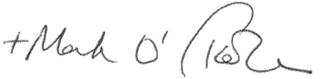

Archbishop of Cardiff and Bishop of Menevia, Mark O’Toole
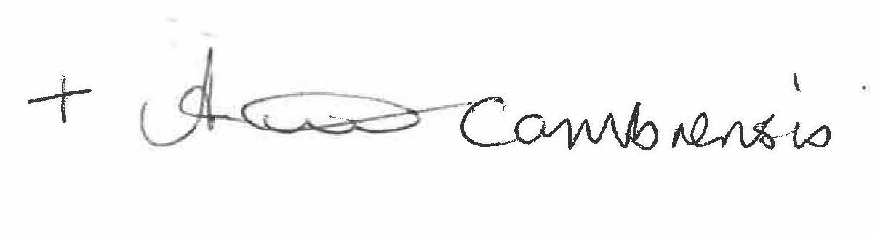

Archbishop of Wales and Bishop of Bangor, Andrew John
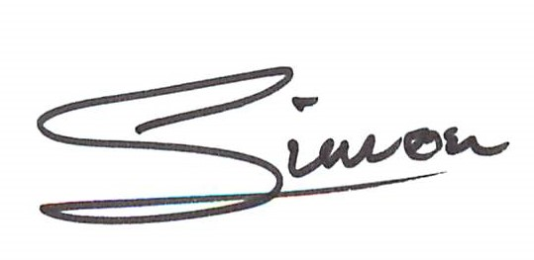
Moderator of the Free Church Council of Wales, Simon Walkling

