DIOCESE OF MONMOUTH

NORTH MONMOUTHSHIRE MINISTRY AREA

CRUCORNEY PASTORAL DISTRICT

PROFILE

Our churches and communities.
Our hopes and aspirations.
The kind of priest we seek.
What we can offer our new priest.

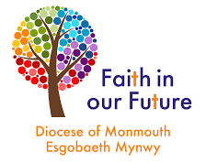

DIOCESE OF MONMOUTH

NORTH MONMOUTHSHIRE MINISTRY AREA

Introduction from the Archdeacon of Monmouth, The Venerable Ian Rees
Thank you for taking the time to look at this profile. We are seeking to appoint a House for Duty Priest Team Priest for the North Monmouthshire Ministry Area based in the beautiful village of Llanfihangel Crucorney.

This post will offer a role as part of a Ministry Team serving a new Ministry Area. It offers an exciting opportunity to work collaboratively with lay and ordained colleagues. The churches where you will primarily be based have worked together for a number of years and we imagine that the close relationship between them will continue whilst they also become active participants in the wider Ministry Area. The Ministry Area is very well served currently by two committed and active stipendiary priests as well as other ordained and lay ministers and we hope that the teamwork already happening in the area will continue to grow.

The area where you will primarily be based has some magnificent history which, given its beauty as well, makes this a very attractive place to minister and live. They are places of great potential and there is a passion to proclaim the Good News in those communities. The people are warm, welcoming and have a genuine desire to grow the Kingdom of God.

For an informal conversation or further information please contact the Ministry Area Leader, The Revd Julian Gray on 01873 859881 or mardyvicarage@yahoo.co.uk

With my best wishes

Ian Rees

The North Monmouthshire Ministry Area. It is envisaged that the North Monmouthshire Ministry Area will be commissioned by the Bishop of Monmouth, The Rt. Revd. Cherry Vann, early in 2023. The Ministry Area will be, in effect, one large parish based on the Rectorial Benefice / Team Ministry model. The move to Ministry Areas is an exciting venture, aimed at establishing sustainable opportunities for ministry and mission locally by sharing our gifts and resources, both human and material, among our eighteen churches. A Ministry Area Transitional Team (MATT) is currently working to implement the significant changes required to bring the North Monmouthshire Ministry Area into being.

The Ministry Area will be geographically large and, apart from the suburb of Mardy on the northern outskirts of Abergavenny, mostly rural and sparsely populated. To enable the Ministry Area to work effectively, it will be sub-divided into five Pastoral Districts, each with several constituent church congregations.

The Pastoral Districts will correspond to the five existing benefices that are in the process of merging to form the Ministry Area. In this way, relationships between churches, congregations and communities that have been forged, in many cases, over several decades will be maintained. However, our aim is to nurture a new sense of belonging and identity as part of the North Monmouthshire Ministry Area. This poses a challenge to our existing parishes and benefices that have, until now, functioned independently of each other. However, we are beginning to realise the advantages of interdependence that belonging to a Ministry Area can offer, and the opportunity it provides for a new partnership in ministry and mission.

The five Pastoral Districts of the North Monmouthshire Ministry Area will be as follows:

Crucorney Pastoral District. St. David Llanthony, St. Martin Cwmyoy, St. Michael Llanfihangel Crucorney. House for Duty Team Vicar with pastoral responsibility: Vacant.

Grosmont & Skenfrith Pastoral District. St. Nicholas Grosmont, St. Bride Skenfrith, St. Mary Lllanfair, St. Cadoc Llangattock Lingoed, Stipendiary Team Vicar with pastoral responsibility: The Revd. Gaynor Burrett.
Llantilio Crossenny Pastoral District. St. Teilo Llantilio Crossenny, St. Cadoc Penrhos, St. James Llanvetherine, St. Mabli Llanvapley. House for Duty Team Vicar with pastoral responsibility: The Revd. Heidi Prince.

Llantilio Pertholey and Llandewi Skirrid Pastoral District. St Teilo Llantilio Pertholey, Bettws Chapel, St. David, Llandewi Skirrid. Stipendiary Team Rector with pastoral responsibility: The Revd. Julian Gray.

Llanddewi Rhydderch Pastoral District. St. David Llandewi Rhydderch, St. Bridget Llansantfraed and Llanarth, St. Cadoc Llangattock-juxta-Usk. House for Duty Team Vicar with pastoral responsibility: The Revd. John Humphries.

Oversight for the North Monmouthshire Ministry Area will be provided by the Team Rector and each of the Pastoral Districts will have a resident Team Vicar as its focal pastor. Additionally, there are several self-supporting Associate Priests, Assistant Priests and Licensed Lay Ministers who will be working in their own Pastoral Districts and throughout the Ministry Area.

At present there are fourteen parochial church councils in the North Monmouthshire Ministry Area but, when the Ministry Area is fully commissioned, these will be replaced by a single governing body known as the Ministry Area Council. However, each church or Pastoral District will have its own Committee and will be encouraged to develop a Local Ministry Team. These local teams will be supported by the Team Rector, Team Vicars and, in due course, a Ministry Area Administrator.

Ministry Area Team Vicar for the Crucorney Pastoral District. A vacancy currently exists for a Ministry Area Team Vicar (house for duty) with responsibility for the Crucorney Pastoral District. We seek a prayerful pastor of spiritual maturity to minister to the churches and closely-knit communities of this beautiful corner of the North Monmouthshire Ministry Area. A passion for rural ministry would be essential, together with a willingness to engage with the community and become an integral part of it.

Although the primary task of the new Vicar will be to care for the congregations, churches and communities of the Crucorney Pastoral District, you would be licenced to the Ministry Area. As such you would also be expected work alongside the Team Rector, fellow Team Vicars and other colleagues, both clerical and lay, to help build and develop the new Ministry Area and its potential for outreach and mission.

You would be asked to offer three days of ministry per week consisting of a Sunday, one and a half days devoted to the Crucorney Pastoral District and a further half day in the wider North Monmouthshire Ministry Area. You would be a key member of the Crucorney Local Ministry Team and of the Ministry Team for the wider Ministry Area. Although mostly leading worship in the churches of the Crucorney Pastoral District, you would also be asked to preside elsewhere, perhaps on one Sunday each month, when the Ministry Area is fully established.

Locality. The North Monmouthshire Ministry Area covers the north-western quadrant of Monmouthshire, bounded on the north by the county of Powys and on the east by the border with Herefordshire. To the southwest, by the northern outskirts of Abergavenny and to the southeast the Ministry Area extends to just north of the A40 over towards the town of Monmouth. Apart from Abergavenny and its satellite settlements, the area is entirely rural with a number of villages and smaller settlements.

A place of pilgrimage. The Llanthony Valley forms the heart of the Crucorney Pastoral District, with its medieval Augustinian priory church. The twelfth century priest and chronicler, Gerald of Wales, described the area as being ‘a wilderness far removed from the bustle of mankind.’ The area has long been a centre of Christian pilgrimage, and many have been drawn here to experience it’s peace and solitude.

The Revd. Joseph Leycester Lyne (better known as Father Ignatius) came to the Llanthony valley during the nineteenth century and established a community of Benedictine monks at Capel-y-ffin. Today, the Father Ignatius Memorial Trust holds an annual pilgrimage to the Valley in August. The Orthodox Parish of the Nativity of the Mother of God celebrates the Divine Liturgy each year in St. David’s Church, Llanthony, in early March. One of our local mountains, Ysgyryd Fawr, known locally as the ‘Holy Mountain’, is said to have acquired its distinctive shape following a landslip that occurred when Jesus died on the cross on Good Friday.

So, this is a very special place, a ‘thin place’ where heaven and earth reach out and touch each other. It is therefore expected that the Team Vicar with responsibility for the Crucorney Pastoral District, together with the Team Rector and Local Ministry Team, would support and encourage this tradition of pilgrimage and explore ways of developing its potential as a means of outreach and mission.

Local school links. St. Michael’s Church has long enjoyed close relationship with Llanfihangel Crucorney Primary School in Pandy. The new Team Vicar will be expected to continue to build on that relationship by regularly leading assemblies and collective worship at the school and welcoming the children, staff and parents when they visit St. Michael’s to celebrate annual events in the Church Calendar such as Christmas, Easter and Harvest.

We therefore seek a Priest who will be:

- Prayerful - having a deep friendship with God, someone who will nourish our own spiritual lives.
- Caring - has a strong pastoral heart and a passion for encouraging the members of each of the congregations in discipleship, building a strong unity in Christ.
- Collaborative in nature - working well both with the Crucorney Local Ministry Team and the wider North Monmouthshire Ministry Area Team and who can work alongside both lay and ordained colleagues. We are seeking someone who is a good team player.
- Community focussed - being a visible presence in the Ministry Area, especially in the Crucorney Pastoral District, helping us to develop both our ministry of service and to be a blessing to our diverse communities and our ministry to all God’s people within them.
- Engaging - has energy and commitment to engage with the local communities and is sympathetic to the needs of rural communities. A priest who is able to help facilitate a growth in cooperation and inter-action within our churches.

We feel strongly that ministering to a rural community is different from serving in an urban area. Many in the community see the church as their church, even if they only attend on ‘high days and holy days.’ The Vicar, therefore, needs to be an integral part of the community, and their ministry is to both the churched and non-churched in the community.

As mentioned earlier, you would be a part of the larger Ministry Area Team with the advantage of wider resources to call upon, together with the opportunity to work alongside colleagues, both clerical and lay, who will support, affirm, and encourage you. You would also be blessed with committed, capable and responsive congregations in the Crucorney Pastoral District.

The Vicarage. In return for your commitment to the North Monmouthshire Ministry Area and the Crucorney Pastoral District, you would be provided with rent free accommodation in the Vicarage pictured below. Council Tax, water rates and expenses of Ministry will be paid in full. The Vicarage is located in the beautiful village of Llanvihangel Crucorney on the A465, some five miles from Abergavenny and twenty miles from Hereford. The property is being totally refurbished and upgraded before the new Team Vicar takes up post. The house is a modern four bedroom detached property, set in its own garden with a drive and garage. It will afford spacious accommodation, offering a home as well as an office for the appointee.
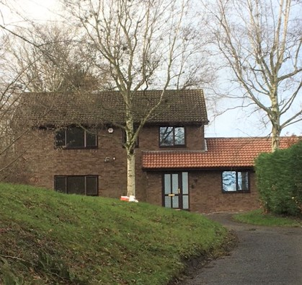

Further details of the locality, the churches and their congregations appear in the attached Appendix 1. Appendix 2 contains financial information for the Crucorney Parish.

APPENDIX 1
Crucorney Pastoral District: locality, churches and people
(Prepared by the PCC)

Locality: North Monmouthshire is an exceptionally beautiful area, sitting within the Brecon Beacons National Park. It nestles among the Black Mountains, with a range of other hills all around. The Llanthony Valley, in which the pastoral district lies, is a rural and farming community with the remains of Llantony Priory at the head of the valley. For those who like the outdoors, it couldn’t be a lovelier place. A number of paths and walking trails thread their way through the area, including Offa’s Dyke and the Beacons Way. The iconic Ysgyryd Fawr (Big Skirrid) mountain, also known as the Holy Mountain, is a dominant local landmark and is easily walkable from the village.

Abergavenny, often referred to as the ‘Gateway to Wales’ is the nearest town, less than 5 miles away from the village of Llanvihangel Crucorney.
Abergavenny serves a hinterland which extends into England, as the border is relatively close to the town. Abergavenny is an excellent market town abounding in history and offering a full range of facilities and good shopping with a selection of supermarkets, multiples and independent shops. Abergavenny is the centre of the northern part of the county which extends into Powys to the north-west and Herefordshire to the east.

Good public transport exists in the area with regular X4 Cardiff to Hereford buses stopping in the village of Llanfihangel Crucorney where, as Team Vicar, you would live. Abergavenny has a railway station with frequent trains to Cardiff, Swansea, Newport, Hereford and other destinations in both Wales and England. London can be reached by train within two-and-a-half hours. Cardiff, the Welsh capital, is a short trip away on the train, making all that the capital has to offer, within easy reach.

Abergavenny is also well connected by road: north to Hereford (20 miles) and south to Newport and the M4 (23 miles), and east – west on the A40 to Monmouth (20 miles) and the A465 Heads of the Valleys Road, with good links further west. The town is a popular tourist destination famous for its annual food festival and an abundance of coffee shops. There is also a theatre, cinemas, music, choirs, dramatic societies, sports and many other clubs and societies.

Further afield we have the other towns of Monmouth, Chepstow and Usk, all thriving market towns with a unique range of shops, pubs and eateries. Crickhowell and Brecon, both market towns in nearby Powys, are also well worth exploring and the Brecon Beacons is a must for those who enjoy the outdoors.

Churches: The Crucorney Pastoral District has three churches: St Michael’s in the village of Llanvihangel Crucorney (which is where the Vicarage is located), St Martin’s at Cwmyoy and St David’s at Llanthony. We feel we have a great opportunity to support the theme of ‘pilgrimage’ here in our very special valley. We have the Skirrid Mountain – otherwise known as the Holy Mountain just outside the village and numerous paths that link our three churches leading from St Michael’s right up to the Priory and St David’s at Llanthony. This may prove to be a theme we can take forward within our Ministry Area with the support of our new Team Vicar.

Llanvihangel Crucorney is a thriving village with a shop and garage, a regular bus service and a local pub - the Skirrid Inn, the most notable in the area, famous for being the oldest pub in Wales and with a very interesting history.

In 1974 the nave roof of St Michael’s church collapsed, and a series of repairs were carried out. However, starting in 1998, with the help of Heritage Lottery funding and a great deal of organisation and fund raising by the then PCC, the church was completely restored, based on how it looked in Victorian times. It is a beautiful church with excellent facilities including a large open circulation space behind the pews at ground level, an upstairs meeting room, two toilets (one with disabled access) and a small kitchen. We look forward to sharing our facilities with others in our soon to be Ministry Area. There is a Eucharist service at St Michael’s every Sunday morning at 11.00am.
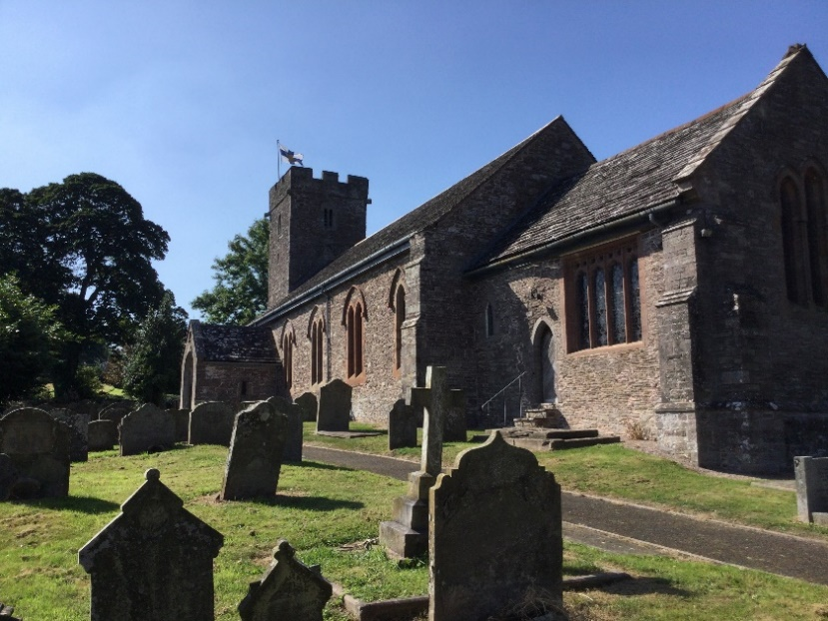

St Martin’s at Cwmyoy is a quaint country church which, having been built on a hillside which is constantly (albeit very slowly) moving, has buttresses to hold it upright! It is said that the tower leans more than the Leaning Tower of Pisa! Cwmyoy is a small hamlet, some 3 miles up the Llantony valley and surrounded by farmland. Prior to the pandemic, a Eucharist service was held every Sunday at 9.30am. Since the easing of Covid measures, we have held a memorial service to our former Church Warden and a Christmas morning Eucharist service. Both were very well attended. We are keen to re-start services there when possible.
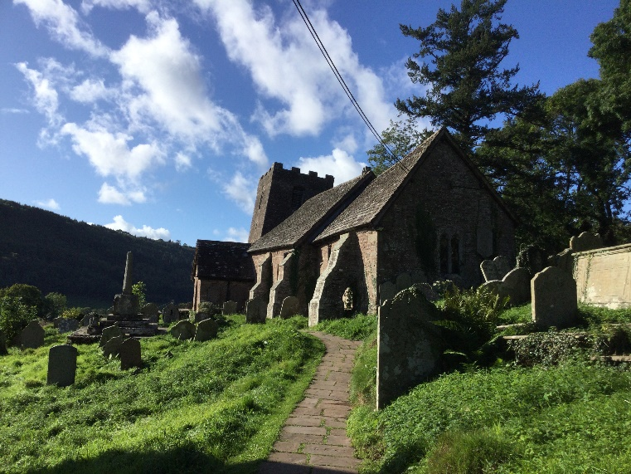
Finally, there’s St David’s at Llanthony, a tiny church with a very big impact. It lies in the shadow of the remains of Llanthony Priory and is very popular with the walkers and holiday makers who stay at the nearby farm campsite. The Llanthony Priory Hotel and nearby Half Moon Inn provide welcome refreshment for visitors. Before the pandemic, there was a monthly service at St David’s held at 8.30am on the first Sunday of the month. Last Christmas Eve, we held our first service in two years at St David’s - our annual parish Carol Service and would like to hold more services when the time is right.
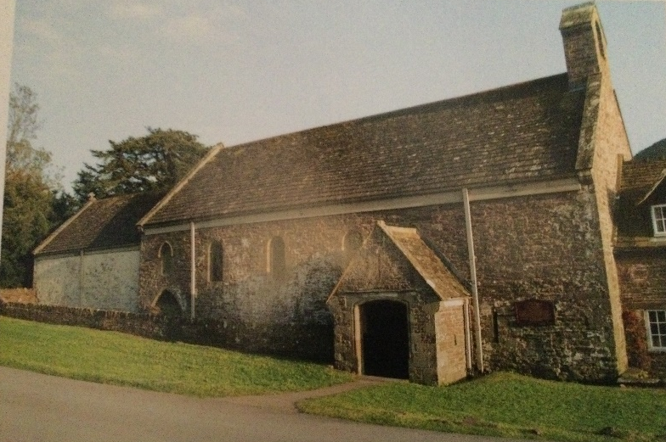
Since church congregations have been able to meet again, the three churches have been having one combined Eucharist service at St Michael’s each Sunday. Both St Martin’s and St David’s are open daily for private prayer and visitors. As we gradually recover from the restrictions of the Covid pandemic, it is hoped that regular worship will return to St. Martin’s and St. David’s during 2022.

The Crucorney Pastoral District is in border country, just five miles to the border with England. There are many incomers and commuters and a higher proportion of the population not born in Wales; it is thus an anglicised area of Wales but very much a part of The Church in Wales. Services are delivered in English.

People: We affirm the ministry of both women and men: both lay and ordained. We strive to be inclusive, collaborative, engaging, inspiring and accessible. We support the formation of Ministry Areas and are actively involved in working groups along with representatives of other churches. We see Ministry Areas as an opportunity and a realistic route to develop our faith and contribution to our wider community and to sustain our church life in this rural part of Monmouthshire.
We are a small congregation, and the pandemic has had the effect of bringing the three churches much closer together. We have an active PCC which has representatives from across the church community. The Parish Report presented at our Parish AGM in May 2021, is available on request and provides a flavour of what had been happening across the parish during the previous year, during which we experienced the Covid-19 pandemic and national lockdown. A draft balance sheet for the Crucorney Parish appears in Appendix 2, along with more detailed income and expenditure balances for St Michael’s and St David’s churches. The PCC is keen to work with our new Team Vicar (and with our Archdeacon and Area Dean during the interregnum) to move forward and grasp the opportunities that present themselves in the future.

In the last year we have also unexpectedly lost some much-loved, long-standing pillars of our church community. But, inspired by their work, their willingness to face challenges and to change and adapt, we have regrouped ready to build on their legacy to us and take our parish forward. This all makes it a perfect time for a new priest to join us and guide us on that mission.

APPENDIX 2
CRUCORNEY PARISH
DRAFT BALANCE SHEET
31 DECEMBER 2021
Investments
COIF |  | 311053
Bank Accounts
COIF Savings | 30221
Current Accounts | 61292
 |  | 91513
Total Funds |  | 402566

St Michael’s Church, Llanvihangel Crucorney
Income & Expenditure: Year ended 31 December 2021

INCOME

Planned Giving | 9267
Loose Collections | 229
Gifts in Memory of Christine  Gifts in Memory of Derek | 1985
Collection for Lent Appeal | 845
Collection for Christmas Cards | 100
Sale of Cards | 127
Fees | 1560
Investment Income | 8369
Gift Aid | 2486
Total Income  EXPENDITURE | 26128
Parish Share | 10356
Parish Expenses | 1288
Altar Requisites | 124
Insurance | 774
Cleaning & cleaner | 1435
Light & Heat | 1868
Repairs | 4440
Churchyard | 3718
Lent appeal | 845
Christmas appeal | 100
Lunch costs and presents net of collections | 166
Deanery subscription | 30
Total expenditure | 25144
Surplus | 984

St David's Church, Llanthony
Income & Expenditure
Year to 31 December 2021

INCOME
Collection 110
Donations 2400
Wall Box 1320
Fees 200
Total Income 4030

EXPENDITURE
Insurance 573
Cleaning 272
Light & Heat 163
Repairs 200
Children's Fund 100
Churchyard 400
Total expenditure 1708

Surplus 2322

