COMMUNION DAY OF PRAYER
30 November 2021 (00:00 – 00:00 UTC)
A 24-hour online global wave of prayer

Christians around the world are preparing to unite

Inspirational films from your Christian community around the world

On Zoom and Facebook Live, we will stand together in prayer

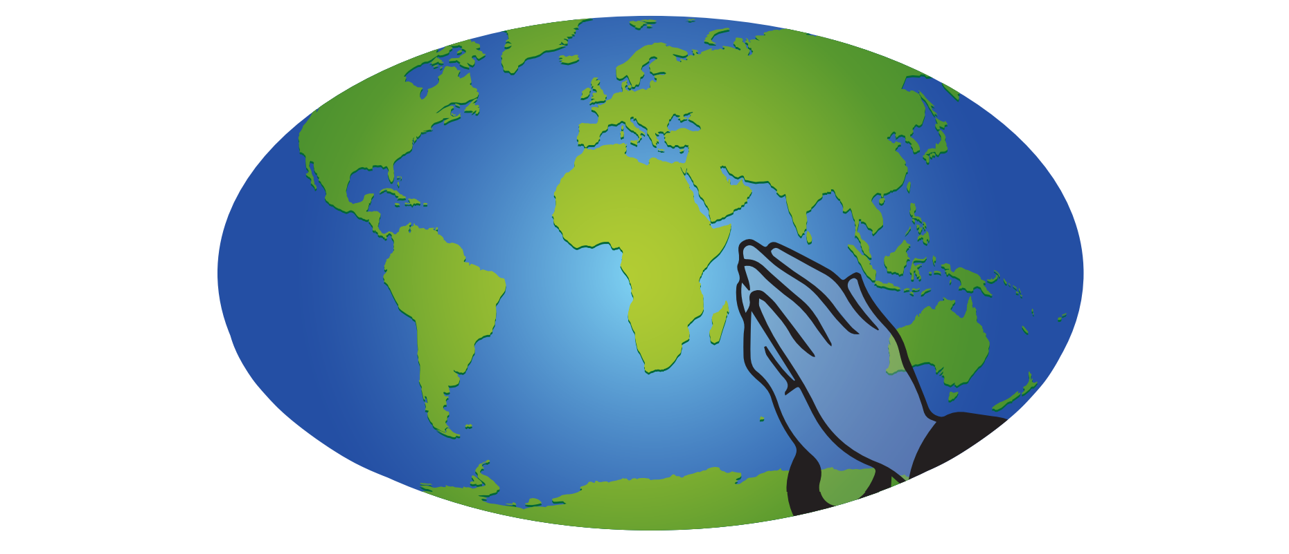

BE A PART OF IT
Join any time through the day – come and go
Watch with friends, family, church – host a prayer watch party!
Listen all day – keep the prayers on as you work or play

OPEN TO ALL. GO TO:
WWW.USPG.ORG.UK/DAY-OF-PRAYER

