The Diocese of Monmouth

NETHERWENT MINISTRY AREA
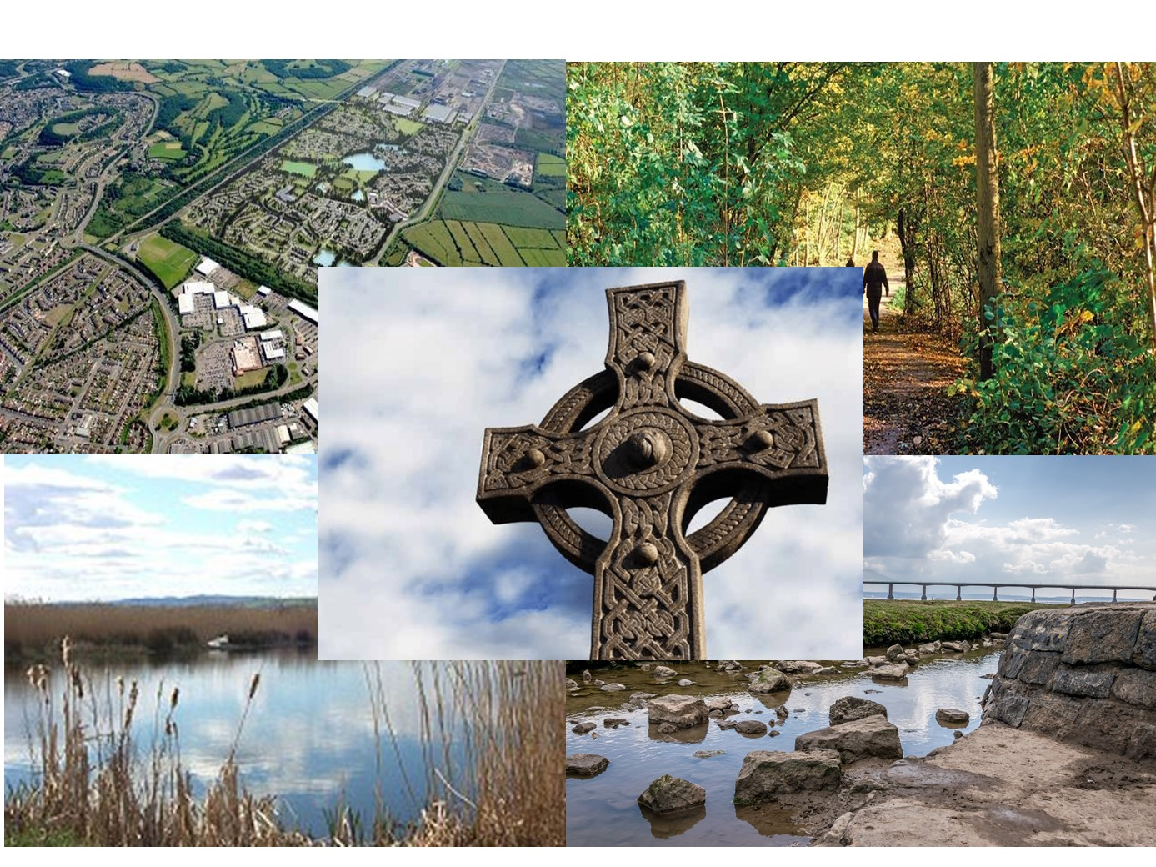

PROFILE FOR THE POST OF
TEAM VICAR

Contents:
Page:
From the Archdeacon of Monmouth 3
New beginnings 4
Our Ministry Area 6
Our new Team Vicar 9
The Vicarage 9
To apply…. 11
Appendix 1: more about our churches and congregations 12
Appendix 2: Worship patterns, attendance figures etc. 21

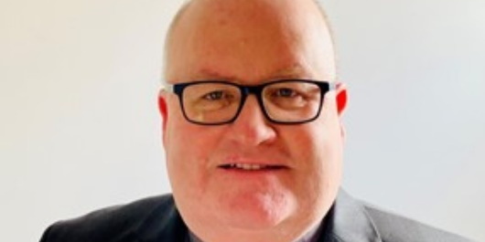

FROM THE ARCHDEACON OF MONMOUTH

Thank you for taking the time to look at this profile for the post of Team Vicar in the Netherwent Ministry Area. This new Ministry Area offers an exciting opportunity to develop collaborative ministry and mission. Whilst a lot of the churches have worked together for some years, the newly formed Ministry Area is growing closer together, realising the benefits of sharing resources, skills and the desire to grow spiritually and numerically. They are embodying the ideal of Unity and Diversity, as a way of celebrating a single desire to be the People of God, but recognising that each church community does this in its own special way. Throughout the current pandemic they have worked hard to support each other in practical and spiritual ways.

The Ministry Area is very well served currently by two committed and active full-time priests: Rev’d Canon Jeremy Harris is the Ministry Area leader and The Rev’d Daniel Frett. There are lots of other gifted potential colleagues for you, both lay and ordained, and the ‘team’ element of the role is very important.

These are beautiful parts of Wales in which to live and minister and also places of great potential and passion to proclaim the Good News in their communities. The people are warm, welcoming and have a genuine desire to grow the Kingdom of God in their communities.

For an informal conversation or further information please contact the Revd Canon Jeremy Harris on 01633 882551 or jeremydharris@hotmail.com

With my best wishes
Ian Rees

NEW BEGINNINGS

‘’WE TRUST GOD TO LEAD US INTO THE NEW AND SHAPE US FOR THE MISSION AND MINISTRY TO WHICH WE ARE CALLED’’

(The Right Reverend Cherry Vann, Bishop of Monmouth)

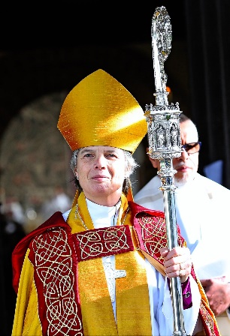

The Diocese of Monmouth is in the process of establishing sixteen new ministry areas across the Diocese. Each Ministry Area will be a single Benefice and Parish and be served by one ministry team working collaboratively with each other and local congregations. Each will have a Ministry Area Council which will comprise of licensed clergy and a good representation of people from our local churches. Each church is encouraged to hold a regular congregational meeting to which much of the day-to-day responsibility for the local church can be delegated by the Ministry Area Council. There is also the option of developing a ‘forum’ to allow a greater number of people from congregations/ communities to have a greater involvement in the corporate life of the Ministry Area.

The Netherwent Ministry Area is due to be formed at the beginning of 2022 as an amalgamation of three existing ministry areas/ groups of churches i.e., the current: Caldicot Benefice, the Magor Ministry Area and most of the Wentwood Ministry Area.

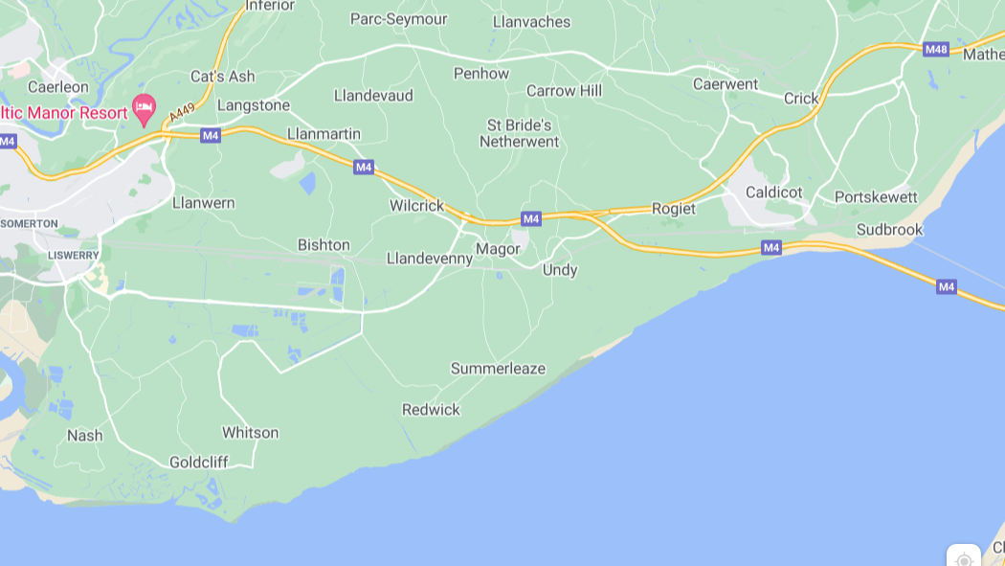

Netherwent (a name dating back to Norman times and meaning ‘Gwent beneath the wood’) is situated in the South-east corner of Wales and covers an area that stretches from Wentwood Forest and Sudbrook in the east in the County of Monmouthshire to Nash, Glan Llyn and Langstone in the west in the City of Newport. The population is approximately 30,500 and from east to west the ministry area is over 15 miles long.
The Ministry Area is made up of several large areas of population together with many smaller villages and hamlets. The M4 motorway passes through the Ministry Area and the Severn Estuary and Wales Coastal Path runs along the most southerly border. The area contains several areas of outstanding natural beauty; the cities of Newport, Cardiff and Bristol are within easy travelling distance and there are excellent transport links to the rest of Wales, London and the Southeast, the Midlands, the Northwest and Northeast. There are several very good schools both at primary and secondary levels, including two Church in Wales Primary Schools and a Welsh Language Primary School. There is also good healthcare provision, an excellent variety of retail outlets and plenty of opportunities to pursue leisure activities.
The population is made up of a mixture of folk, some who have always lived here (many with farming connections), those working in local businesses, commuters working in Bristol, Newport, Cardiff and further afield and those who have decided to retire here. The building of new housing has dramatically increased the population over the past few decades and further developments are either already underway or planned to commence in the coming years.
Despite the population growth the village 'feel' has been largely maintained and people say they feel welcomed and settle here readily. Strong supportive communities are a feature of this area, and you would be sure of an enthusiastic welcome!
OUR MINISTRY AREA

The Netherwent Ministry Area will comprise of nineteen churches and each of our congregations were invited to provide a short introduction to themselves – please see appendix 1. Further details of each of our church buildings and congregations can also be found on our websites.
The Revd Canon Jeremy Harris is the Ministry Area Leader, and the clergy team will consist of two team vicars, one house for duty and one non- stipendiary associate priests, two non-stipendiary curates and a final year stipendiary curate. In addition, there are nine priests living locally who hold permission to officiate, many of whom lead a service once or twice a month. We also have eight Licensed Lay Ministers (Readers) and a further seven Lay Eucharistic Ministers.
You can find further information about us and view some of our on-line services through our websites and social media channels: -
www.caldicot-benefice.org.uk
www.magorministryarea.org.uk
www.wentwood.church
St Mary's Caldicot, Portskewett & Rogiet/ Magor Ministry Area/ Wentwood Ministry Area
@MagorMin @Wentwood

Our vision as an emerging ministry area is to equip each of our local churches to be warm and welcoming faith communities, reaching out and connecting with the wider population and manifesting God’s love for all. We want to be inclusive, relevant, attractive and easy to engage with.
Together we want to be a united and strong Ministry Area; realising the strengths in us working together and exploring how we can best use the opportunities presented to share resources to help us to grow in faith and love.
Our buildings are much loved and well cared for. Eighteen of them are listed buildings and most are structurally in very good condition although a few are now in need of more substantial repair. In general, our local communities are very supportive of the presence of the church in their community and even if they don’t choose to worship with us regularly are happy to support building projects, special events and fundraising activities. We also have several church halls which provide a good resource for both church and wider community use.
The church is the focus of community activity in many of our communities and a wide number and variety of spiritual and secular events are organised throughout the year. Average Sunday attendance figures do not tell the story of the relevance, outreach and engagement with the wider community, who may not attend services regularly, but do come to concerts, fetes, lunches, coffee mornings and teas and who feel a sense of belonging to and ownership of the local church. Groups of local churches have been working together for many years and support each other’s activities and events.
Worship is centred upon the time when we gather together both on Sundays and other days of the week. We are also aware that a growing number of people are not able or may not wish to attend a service in person, and so we want to continue to offer online worship. There are a variety of different styles of worship in our churches and our aim is to provide worship that is vibrant and relevant with a strong emphasis on the ministry of Word and Sacrament. Services are led both by ordained clergy and licensed lay ministers and people are strongly encouraged to take part by reading, acting as sides-people, leading intercessions, assisting in the offertory, chalice assistants, playing musical instruments, singing, bell ringing etc.
Across the new Ministry Area there will be approximately eighteen services each Sunday (average adult attendance of approximately 285 people and 15 children based on 2019 figures). We also have five mid-week services as well as numerous other groups meeting together for fellowship and study. When there is a 5th Sunday each of the church groupings that will form the new Ministry Area have traditionally met together for a united service and we are keen to think further about how this might look in the future.
A more detailed analysis of our service pattern can be found in appendix 2.
Festival services and occasional offices often draw large attendances from the local community and festival services during Christmas, Easter, Harvest, Remembrance etc are often highlights of the year. Our churches are also popular venues for weddings and funerals and many families bring their children to be Baptised. We are keen to further develop our links through such opportunities.

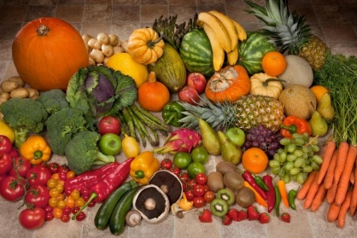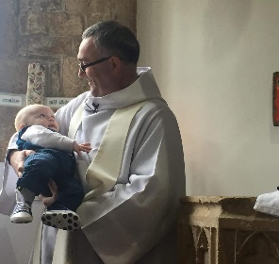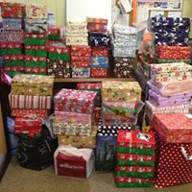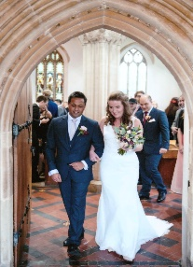

Children and young families are important to us and an area we want to develop further. Our work with them is mainly centred around our All-Age services, children’s groups, Messy Church and visiting local schools.
There are currently eleven primary schools and one secondary school within the Ministry Area and members of our ministry team regularly visit many of them to lead collective worship/ assemblies: a licensed lay minister acts as chaplain to the secondary school in Caldicot. We have two Church in Wales Primary Schools (Magor and Portskewett) and pro-actively support them. We also have good links with many of the uniformed organisations (Scouting, Guiding, Air Cadets etc).
Change and opportunity; several of our communities are growing substantially as a result of new housing development, bringing younger families and young singles/couples. This provides us with a good opportunity to engage with and help to create new, more diverse and stronger communities with the church at its heart. Other villages are rising to the challenges brought by an older population, finding practical and innovative ways to support each other. We want to explore how we can offer new activities and worship to our communities, reflecting the fact that we don’t simply want to just provide a service in church every week. Growing as disciples is a key part of our Diocesan strategy as we move forward and something we want to develop further within the Ministry Area.
Financially we are solvent, and our ministry share payments are up to date. We do however recognise that there is work to be done to ensure that all of our churches remain financially sustainable for the future.
Strong ecumenical links; numerous joint services, study groups, talks and social gatherings happen between our churches and other local faith-based groups. This is important to us.
And… we have several other groups that meet regularly including coffee morning & social events; craft groups; mother and toddler groups; bell ringers and a church choir. We are blessed to have three active branches of the Mothers Union in the new Ministry Area. Many of these events attract a good attendance of people who choose not to attend regular church services.
We know that there are challenges to be faced as we move forward but are also able to recognise the many opportunities that exist. Many of our local churches have worked well together for some time and there is real determination to face up to the challenges and a growing desire for belonging and growing together. We recognise that there is much work to be done but there is a strong desire to move forward, to look outwards and to grow.

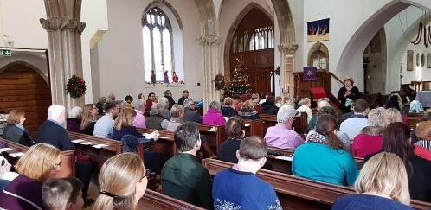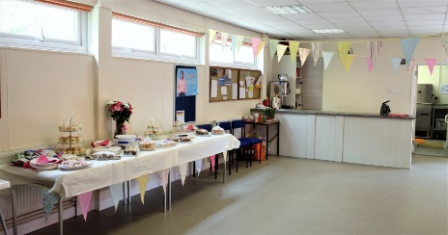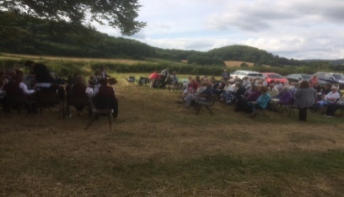

OUR NEW TEAM VICAR
With the restructuring of the Diocese and the creation of our new Ministry Area we wanting to develop a sustainable model of ministry through building a team of lay and ordained ministers with different and complementary gifts but who will work collaboratively together. The flourishing of all God’s people is at the heart of our vision for the future.

All licensed clergy and lay ministers will be licensed by Bishop Cherry to serve collectively across the new Ministry Area and there will be a need for flexibility in responsibilities; however, we also recognise the vital importance of local ‘presence’ and of building relationships with both worshippers and our wider communities. Each church and community will have a small group of ordained and lay ministers who will work alongside other church officers as a ‘focal ministry’ team. And so, we are looking to recruit a new Team Vicar whose main focus will be mainly on the churches and communities in the North of the Ministry Area and so a desire to work with rural communities is important.
We are open to all applicants, regardless of gender or relationship status.
We are looking for someone who: -
- Has a strong faith and a heart for community, for mission and for nurturing disciples.
- Has a servant-heart, who is confident, possesses good relational skills and who is prepared to be ‘hands-on’ whilst not losing sight of the ‘bigger picture’.
- Has excellent interpersonal skills including the ability to foster vocations and to build relationships with colleagues, church members and the wider community.
- Has an understanding of and a desire to work with rural communities.
- The ability to forge, maintain and develop good relationships with people of all ages including schools, young people and their families.
- Will recognise the contribution and value of each individual church, whilst also seeking to foster a sense of unity and purpose across the Ministry Area as a whole.
- Recognises the importance of teamwork and collaborative ministry, including the ability to motivate, inspire and effectively co-ordinate volunteers, colleagues and community partners.

In return you will: -
- Be well supported by colleagues, church officers and our local congregations.
- Be encouraged to continue to develop your skills through our diocesan programme of continuing ministerial development and other opportunities.
- Receive the standard remuneration package of a Team Vicar in the Church in Wales.
- Receive expenses in accordance with the Church in Wales policy.
- Receive fees for weddings and funerals conducted.

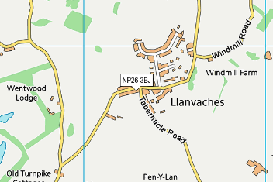 THE RECTORY
There is a lovely large modern four bed roomed house situated in the village of Llanvaches in the North of the ministry area.
Llanvaches is an attractive village situated just a mile from the A48 which provides easy access to the M4 and other main transport links. The nearest station is Severn Tunnel Junction just a few miles away. Excellent local schools; a good range of shops, food outlets, restaurants; healthcare and leisure facilities are available within easy travelling distance of the village.

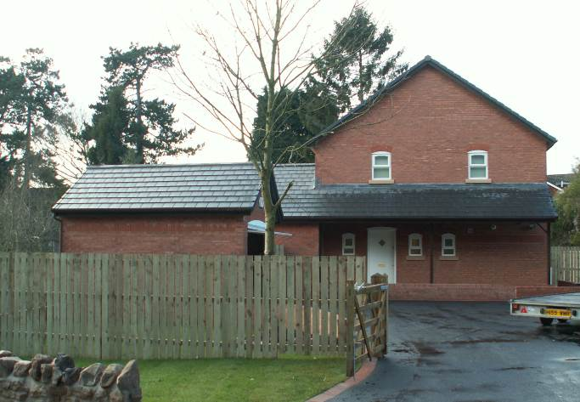

Address: The Rectory, Llanvaches, NP26 3AY

Style: Detached, two-storey house

Bedrooms: Four

Bathrooms: One bathroom and one shower room

Kitchen: Fitted kitchen with separate utility room

Study: Access to study and cloakroom from the porch

Date built: 2006
Heating and hot water: Gas combi boiler, gas fire to sitting room

EPC rating: C

Drainage: Cesspit (maintained by the Diocesan Parsonage Board)

Garage: Detached, single

Boundaries: Mixture of stone and timber
Grounds: Level to front and rear
Trees: Ornamental

Drive and parking spaces: Tarmacadam drive with room for four cars

TO APPLY…

We would welcome the opportunity to chat to you further about this opportunity. For an informal conversation please contact Revd Canon Jeremy Harris (jeremydharris@hotmail.com 01633 882551)

The detailed job description, person specification & application form can be found at https://monmouth.churchinwales.org.uk/en/about-us/jobs/ or from the Venerable Ian Rees (archdeacon.monmouth@churchinwales.org.uk)

The application form and personal statement, should be returned to the Venerable ian Rees by 10th December 2021.

Interviews dates to be agreed. Please indicate if you have any difficulty in attending on that date. If you have any additional needs with regards to taking part in the interview process, please let us know and we will make every reasonable effort to accommodate.

And so…. might this be the right opportunity for you?
We look forward to hearing from you!

Appendix 1.
The Church isn’t the building, it’s the people. That being said we are fortunate to have 19 wonderful church buildings which our church communities call home. They’re all very different but all of them have been used as places of Christian worship for hundreds of years, reminding us of our connection to the wider family of God.
Whether people come to one of our regular services, visit for a wedding, baptism or funeral, or just want to pop in for a look around we want to make everyone welcome.
St Cadwaladr, Bishton.
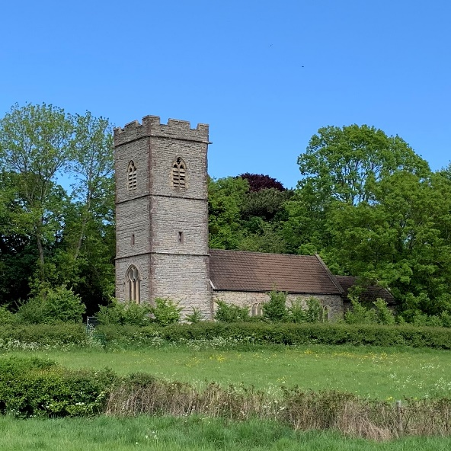
Bishton is a small village nestled in the Gwent Levels and the church has been at the heart of village life for hundreds of years. A service is held every other Sunday and the church is kept open for visitors for much of the year. The local community are good at supporting the church and a local group are currently raising funds to carry out necessary significant repairs to the church tower. The church is home to an exhibition about the history of the local community and the life of St Cadwaladr and we hope this may give us opportunities in the future to welcome more visitors.
St Brides Netherwent, St Brigid.
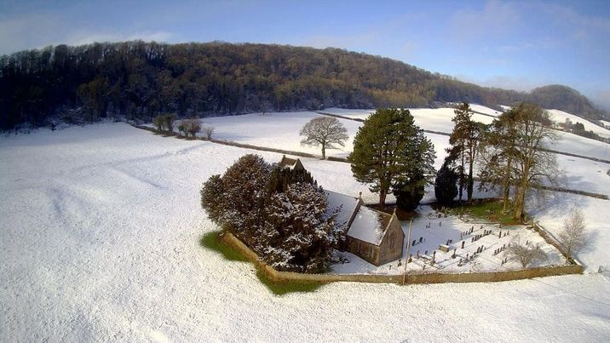
The church is in a beautiful rural setting – in the middle of a meadow, surrounded by a scheduled ancient monument. With a small and scattered population (circa 220 spread over a large area), attendances at Sunday services are very healthy. One regular service is held once a month. Services such as Harvest Festival, Easter and Christmas and a range of special services and events attract large congregations.
Financial and other practical support is readily given by the wider community and community events are popular and attended by a large proportion of the population.
Caerwent, St Stephen and St Tathan.
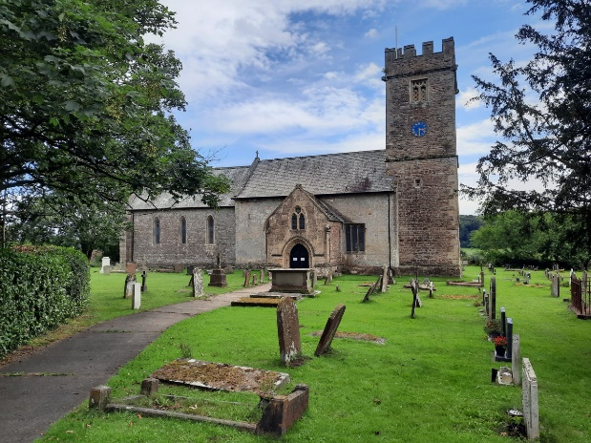
The church is situated on what is probably the earliest Christian site in the county, possibly even in Wales. Erected in the 13th century and surrounded by the Roman village of Caerwent, the church holds many Roman artefacts, and is open daily, so attracting visitors both locally and worldwide. The welcoming atmosphere has been enhanced over recent years with the addition of more comfortable seating, a small kitchen area and toilet facilities. Services are held each Sunday and a mid-week Eucharist, with refreshments served after Sunday morning services. The church has a Nicholson pipe organ - impressive for a rural parish - and there is a strong musical tradition here, the church being large enough to provide a venue for a range of musical concerts and other social events, these always being well supported by the wider local community with whom we have very good links. Our regular activities include Mothers’ Union, Village Lunches and Coffee Mornings. We pride ourselves on being a warm and friendly church community, always keen to welcome new faces and families.

Caldicot, St Mary’s.
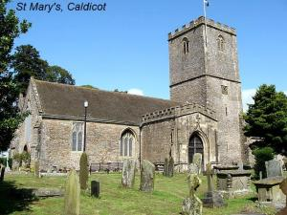

A church has stood on the current site since before 900AD with parts of the current building dating back to the thirteenth century. In recent years the church has been undergoing some re-ordering: the electronic organ has been moved down to the nave; chairs have been installed at the front; architects plans have been commissioned to integrate the south porch with glass doors, restore the original aspect of the east window, and an electronic screen, projector and the ability to livestream have recently been installed all as part of a project to make the church more accessible to a wider range of people and enhance its role as a venue for all its parishioners whether church-goers or not. There is also a church hall situated close to the church which is used for several church events/ groups as well the wider community.

Goldcliff, St Mary Magdalene Church.

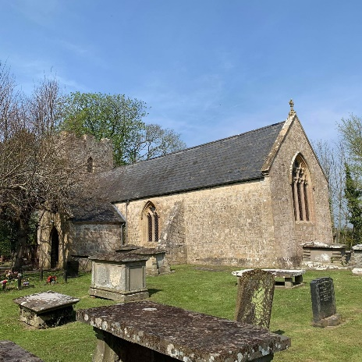

A 13th Century Grade 2 listed building in a semi-rural location. The Church is supported by a small ageing congregation who faithfully attend services on two Sundays a month alternate Thursdays and Bible studies. The church is popular and well attended for special occasions such as Harvest and Christmas.

Llandevaud, St. Peters.
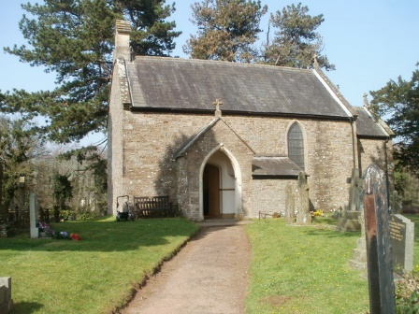
A warm and welcoming small Church situated just off the A48. We hold two services a month: A morning Eucharist and an afternoon All age service. We are a relatively small community, but we have a large number of people who support our fundraising events, social occasions and festival services. We have a lovely, newly refurbished Church hall situated alongside the Church and hope this hope this will provide a vital link between the Church and village.

Llanvair Discoed, St Mary’s.
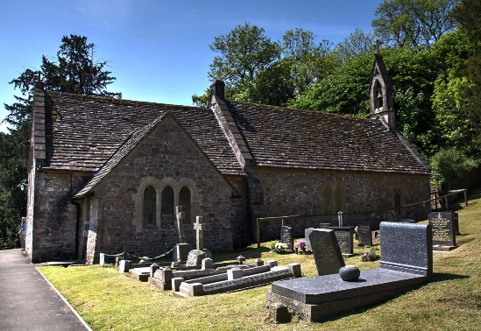

We are a small semi-rural village with a population of approximately 220 and the church is the only communal meeting place in the village. It is therefore an important part of the community and enjoys enthusiastic support from most members of the village at social and fund-raising events. We hold a service each Sunday and once a month serve refreshments following the service. The church is open every day and get a surprising number of world-wide visitors who leave very encouraging comments. It’s important to us that the church is seen as a place for everyone our pews have been removed so that the church can be used for social events. The Harvest Festival Service, followed by supper, and the Christmas carols are a village tradition and much enjoyed. When new people come to live in the village, they are visited by someone from the church and kept informed about what’s happening.
Llanmartin, St Martin.

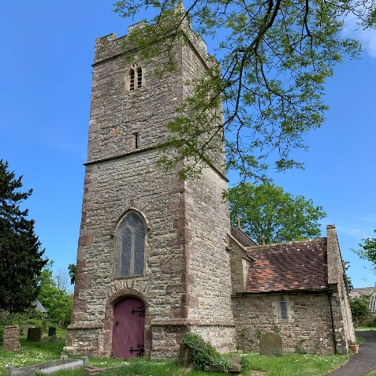

The Church is situated in a rural location just off the A48 but only down the hill from the large population of Underwood. It’s a typical village Church, seating about 50 people for special occasions and we hold a service each Sunday. We also attract the followers of Langstone Church which closed recently and hold a monthly All-Age service which is always well attended. We like to think of ourselves as a friendly and very welcoming congregation.

Llanvaches, St Dyfrig (Dubritius).
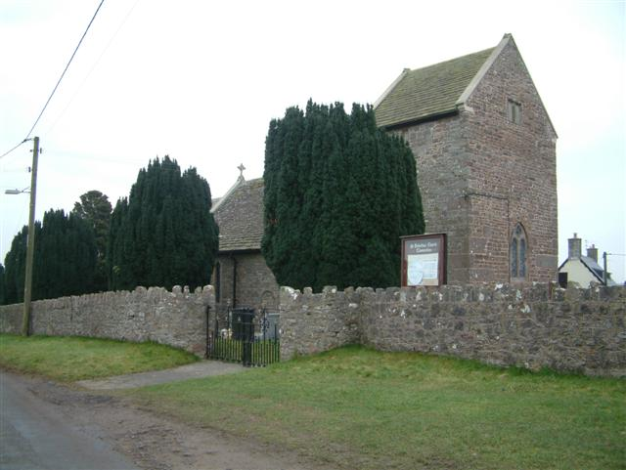
The church is in the middle of this small village with the church hall bedside it. We hold 2 services a week: A Eucharist, All age service or cafe service on a Sunday and Eucharist each Wednesday. Congregations are small, 24 when everyone comes, and we average about 12. More for All age and cafe services the latter being held at 4 pm in the hall. Very helpful village people who attend all events or coffee mornings, book sales harvest suppers etc .and give generously of their time and money!
Llanwern St Mary's.

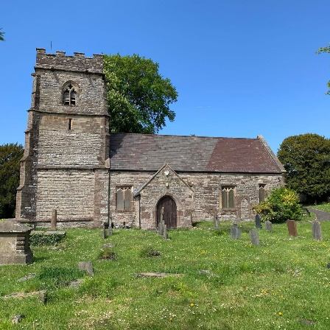

We are a 12th Century church located on the perimeter of the village. Whilst congregation numbers have dwindled over the years, we do have a small but very loyal congregation. We meet once a month for a Eucharist service and in recent years we have hosted a number of very successful harvest suppers and a memorial service such as celebrating 100 years of the suffragette movement. The once small village is growing rapidly with a large new build housing development (including a primary school) and we hope to welcome and engage the new community into the Church.

Magor, St Mary’s.
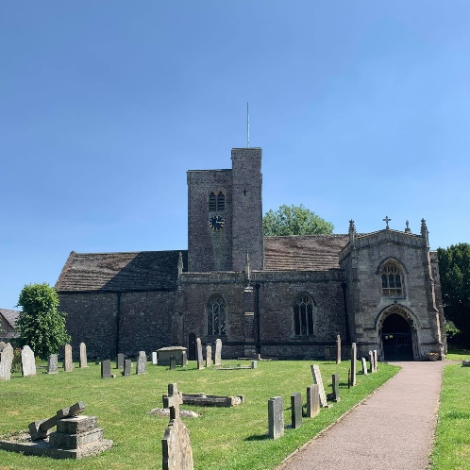
Christian worship has been offered on the site of the current church since the 7th Century. The grade 1 listed building is open daily for visitors and private prayer as well as well as weekly Sunday and mid-week services. We have a well-equipped adjacent church centre which is well used by church and community. Our regular activities include our children’s group ‘Club Rock’, 2 parent and toddler groups, Messy Church, Mothers Union, Ladies Circles, A ‘Cake Saturday’, a monthly lunch club, church choir and bell ringing. We have good relationships with our local communities and consider ourselves to be an outward focussed congregation.
Nash, St Mary’s.
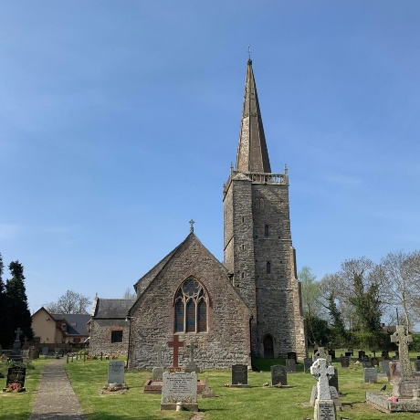
St Mary’s is a large, impressive, grade 1 listed church building which has served the community of Nash for hundreds of years. A major restoration of the Georgian interior has taken place and some further work is planned; we want the church to remain at the centre of village life for many years to come. We hold a weekly service and are pleased to welcome many visitors for major festivals and other events. The church has a good relationship with the local community and the large village hall is often used for church functions. The church building is opened daily at certain times of the year, and we would like to build on our ministry of welcome to the many thousands of visitors to the neighbouring Newport Wetlands.

Penhow, St John the Baptist.
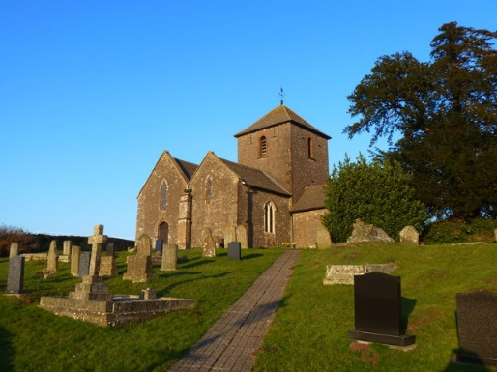
Ours is largely a rural Parish, the church building dates from 1200 and is a sacred place for quiet contemplation and focus of faith. The Church is situated about a mile from the main area of population and a large part of which are retired people but there are also families with children as well as professionals, farming and other small businesses. We are a loyal, courageous, happy and welcoming congregation and there is much work being done/ planned to improve the church structure and facilities. Church members are enquiring, adaptable and make innovative ways of outreaching into the community. We hold regular Bible/ study groups and fund-raising projects which involve the wider community. We are keen to further develop our mission to the wider community and a prayer group has been formed to pray further about this and how we can best adapt to the changes we face.

Portskewett, St Mary’s.
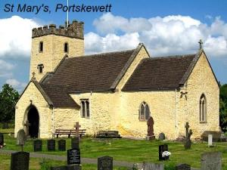

Our church is rich in ancient and modern history, mainly Norman and considered to be one of the best examples of early architecture in South Wales. In close proximity to the church is a grade two listed 17th century cottage which has been renovated to house the Portskewett Heritage Centre and provide the church with a much-needed toilet and kitchenette. We also have a well-used church hall in the village and strong links with nearby Archbishop Rowan Williams Church in Wales Primary School.

Redwick, St Thomas the Apostle.
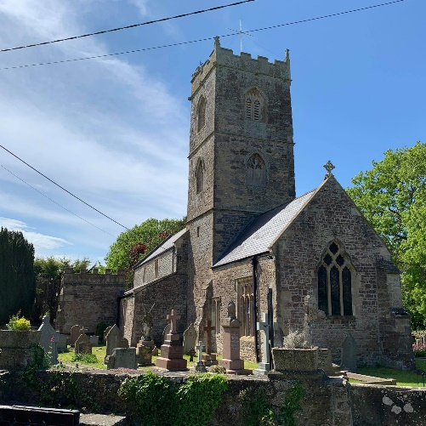
Our church is situated at the heart of the lovely and unspoilt village of Redwick on the Gwent Levels. The grade 1 building is large for a village of our size and makes a good venue for special occasions and regular concerts. We hold two services a month which attract a faithful regular congregation many of whom are part of the local farming community or have retired here. The church, village hall and local pub are all located in close vicinity to each other and strongly support one another. Pre-covid the church was open daily and attracted many people visiting the area.
Rogiet, St Mary’s,
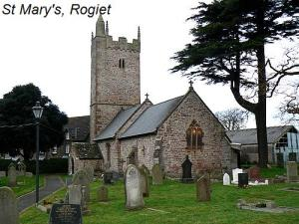

St. Mary’s is a charming and unpretentious little country church dating mainly from the thirteenth century standing in the corner of its large church yard adjacent to the manor house. It’s a typical small manorial church of chancel, nave and western tower, but very beautiful in its own right! It has a very faithful congregation who hold a weekly service in the church. In the village there is a church hall which has become a hub for much community activity.

Undy, St Mary’s.
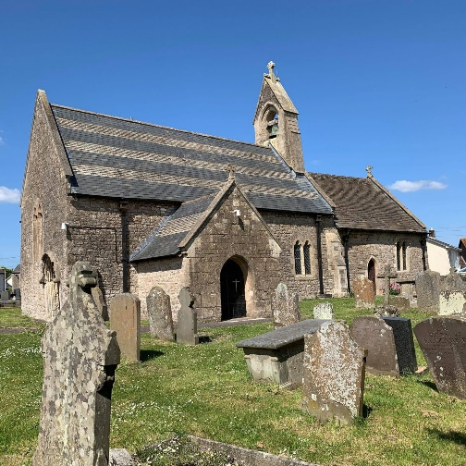
Situated on the southern edge of the village the church dates from the 12th century and is open daily for visitors. We hold weekly services on both Sunday morning and evening and a Thursday morning, and our Sunday services are well attended. In the past we have held a number of social/ fundraising events each year and these are well supported by our wider community.
Wilcrick, St Marys.

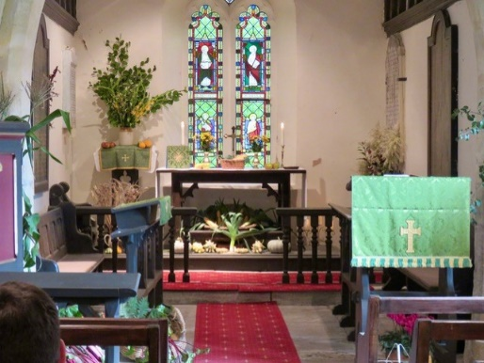
Wilcrick is a very small rural church and a very small population. We hold a monthly Eucharist service at 8am on the first Sunday of every month with a congregation of 6 to 12. We also hold a Carol Service, Easter Sunday and a Harvest Festival, with much larger congregations, all of which end up with tea and cake.

APPENDIX 2.
Worship Pattern (pre Covid)
 | Service Pattern | Average Sunday Attendance per service (2019)
Bishton – St Cadwaladr | Twice monthly | 10
St, Brides – St Bridget | Once a month | 7
Caerwent – St Stephen and St Tathan | Twice each Sunday and mid-week | 27
Caldicot – St Mary | Twice each Sunday and mid-week | 55
Goldcliff – St Mary Magdalene | Twice monthly on Sunday and twice mid-week | 9
Langstone | Occasional services only since 2019. (Monthly service in the village hall) | 0
Llandevaud – St Peter | Twice monthly | 6
Llanmartin – St Martin | Each Sunday | 10
Llanvaches – St Dyfrig (Dubritius) | Each Sunday and mid-week | 10
Llanvair Discoed -St Mary | Each Sunday | 8
Llanwern – St Mary | Once a month | 4
Magor – St Mary | Once each Sunday and mid-week | 47
Nash – St Mary | Each Sunday | 8
Penhow – St John the Baptist | Each Sunday | 16
Portskewett – St Mary | Each Sunday | 27
Redwick – St Thomas the Apostle | Twice monthly | 13
Rogiet – St Mary | Each Sunday | 21
Undy – St Mary | Twice a Sunday and mid-week | 30
Wilcrick – St Mary | Once a month | 8

Estimated number of children attending Sunday services – 15
Baptisms – 90
Weddings – 35
Funerals (church and crematorium) - 120

