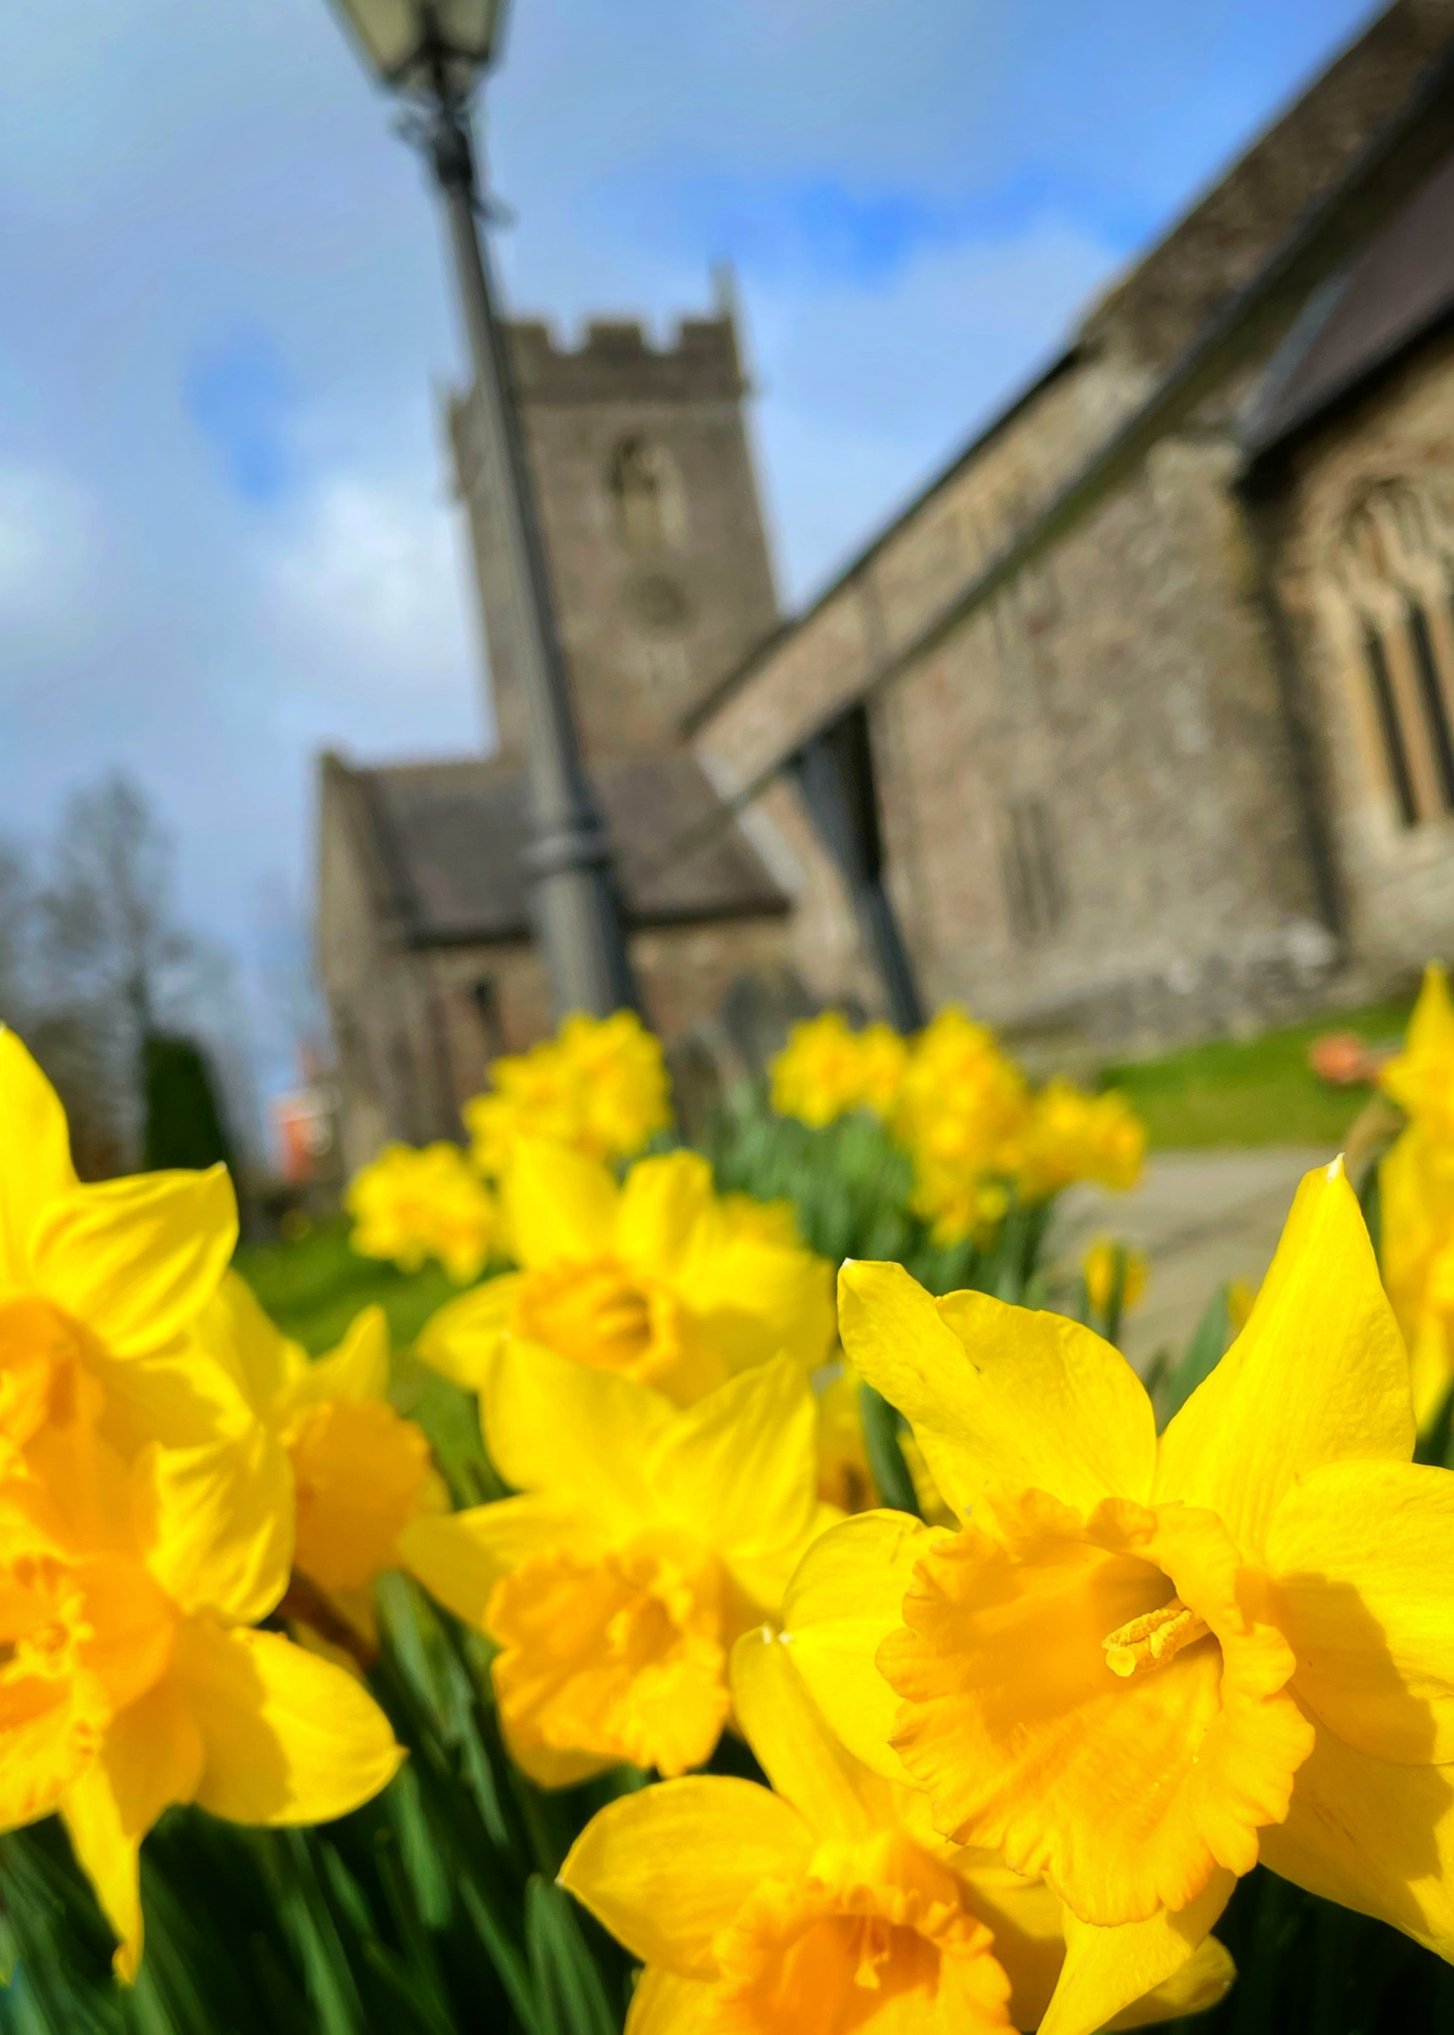
Diocese of Monmouth
The Church in Wales

Upper Eastern Valleys
Ministry Area
Recruitment Pack

November 2021

Welcome
in the name of Jesus Christ!

From the Bishop of Monmouth

The Rt Revd. Cherry Vann

Thank you for taking the time to look at this profile for the significant post of Ministry Area Leader in the proposed Upper Eastern Valleys Ministry Area.

There is tremendous potential in this Ministry Area. The post of Ministry Area Leader offers an exciting opportunity to develop and oversee ministry and mission that is truly collaborative between ministers, ordained and lay, and across the various congregations. Some of the churches in this group have been used to working together. Others are now joining them, and they are beginning to work together as a larger group.

There is a general recognition of the benefits of growing closer together, not least in sharing resources, skills and growing together both spiritually and numerically. In addition, the churches would like to extend their existing mission by learning from and working with the two full time Church Army workers who are establishing a Centre of Mission in the Ministry Area. The Ministry Area Leader will play a key role in encouraging and facilitating all of this.

The post is not without its challenges. Whilst there is a good community spirit and some outstandingly beautiful areas, many of the communities face issues relating to poverty and deprivation. However, there is history of working hard together to address and tackle these issues and the Church looks to be an integral part of that.

You will have the support of an excellent Area Dean and Clergy Chapter, alongside the encouragement of the Acting Archdeacon, Ian Rees. I hope you will consider prayerfully if you are being called to the Upper Eastern Valleys. They are places of passion, beauty and poetry. The people are warm, welcoming and have a genuine desire to grow the Kingdom of God in their communities.

For an informal conversation or further information please contact the Archdeacon on 07983 684151 or archdeacon.monmouth@churchinwales.org.uk

Be assured of my prayers as you consider whether this is where God is calling you to serve Him.

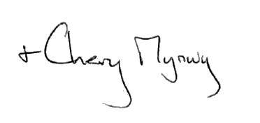
Introduction

Welcome to the Upper Eastern Valleys Ministry Area, a family of churches in the Diocese of Monmouth. The role will involve bringing together churches from 3 areas who have been working together for a number of years. Excitingly, it also involves helping to develop and integrate the work of the relatively new Church Army Centre of Mission.

For the past five years, our Diocese has been on the journey towards establishing Ministry Areas, with a renewed energy to complete this work during the past twelve months. This, we believe, means working more closely together, sharing the resources that we have with one another and benefitting from the significant economies of scale that Ministry Areas will give us. It will also involve discovering ways of being church, of nurturing disciples, and of engaging with our communities that will help us to connect with at least some of the 99.9% of population who aren’t members of the Church.

Ministry Areas are not about managing decline, but about enabling growth by offering support and encouragement as well as lots of practical resources to each other. They are a way of using the gifts of all for the benefit of all.

As a result of the interregnum this work has not really begun properly in this area although people here are well aware of what is planned and are ready to work with a new Ministry Area Leader to develop the Ministry Area. There is also a vacancy for an Associate Priest in the area but we would rather wait for the input of the new Ministry Area leader before advertising this role.

The new Ministry Area covers the areas in and around the largely post industrial communities of Ebbw Vale, Abertillery and Blaenavon. The people of the Ministry Area are very much looking forward to welcoming a new leader who will help them move forward into a new phase of ministry. As churches within the local communities, they have a strong history and wish to develop this further.

There are many opportunities in the area for mission and growth. There is a good team of lay people and a real desire to involve the churches even further with the communities.

The people of the churches are looking for a new priest who will help lead the Ministry Area through the development stage into a period of mission and growth by:

- helping to create a strong sense of unity between the churches
- continuing the churches tradition of pastoral ministry and Christian witness to people in our communities
- being a pastor to love the existing church members, while encouraging them to discover their own vocations and gifts
- encourage them, as they grow in discipleship
- continuing to engage with and develop the community social action activities within the area
- engaging enthusiastically with the ministry to schools and with children
- continuing to foster the parishes strong links with the other Christian congregations
- to develop the use of our buildings for mission and community use.

We have put together this profile to help you see if God is calling you to lead us. If you feel this might be you, we are ready to welcome you to our church family.

The person we would like for this role:

It is important to us that we have the person in post who feels called to our area and will join us as one of our church family. We have walked in faith, through challenging times, and managed without a Priest, so we are strong congregations looking for a strong leader. We need a Priest who can help address our weaknesses, as well as build on our considerable strengths. We feel now is the time to embrace change and develop our potential for spiritual, missional and numerical growth. We are open to all applicants, regardless of gender or marital status, but are eager to recruit someone with a strong faith and a heart for God. We are open to applicants from Wales, the rest of the UK or from further afield.

We recognise that the church exists as much for the people who do not come every Sunday as for those who do, and so we would like actively to explore new ways of connecting with the wider area. We would like to strengthen the church’s recognised, active and welcoming presence in our communities.

We want to increase our presence in the lives of the people of the Upper Eastern Valleys and would encourage people to come to our services and activities. We would also like to continue to expand and develop our ministry to schools, families and young people in our communities.
We are excited about the development of a Ministry Area and are fully committed to growing our relationships with fellow Christians.

Experience
- An appreciation of parish ministry and community relations, and the ability to develop the church’s role and forge links within the community
- Engagement with and pastoral support for people of all ages

Knowledge, Skills and Competencies
- Excellent interpersonal skills including the ability to build relationships with parishioners and community groups as well as senior figures within the wider Church
- Leadership and team-working skills – including the ability to motivate, inspire and effectively co-ordinate volunteers, colleagues, community organisations and members of other denominations
- The ability to forge, maintain and develop good relationships with schools, young people and their families within the Ministry Area
- Ability to think strategically, turning ideas and possibilities into clear and implementable plans
- The ability to inspire, encourage and equip parishioners to assist with the running of the parish and to take ownership of parish activities and initiatives
- The ability to draw the best from a range of worship traditions, and preach in a variety of styles to a broad range of listeners
- Good organisational skills
- Excellent communication skills, including ICT literacy
- UK driving licence

General Attributes
- The vision to drive and facilitate change
- Enthusiastic about inclusivity, equality and diversity
- High emotional intelligence and resilience
- Willingness to be flexible in working practices, e.g. hours of work
- Enthusiasm and energy to be fully involved in parish activities

One personal quality we really hope you have is a sense of humour.

We can’t wait to share a laugh with you and see you build a relationship with each and every one of us. We believe it all starts with a cup of tea and a piece of cake (we have the best in town!) We are realistic that change and growth can cause uncertainty and even conflict, but it also brings joy and celebration. We are loving and loyal congregations, who will support and walk with our new priest.

Our Valleys hospitality is some of the best and we assure you of a Warm Welcome.
We want a Ministry Area Leader (MAL) who will help us move forward, will be loving and not afraid to challenge us. We want to grow in discipleship and Christian witness to our neighbours and communities. We want our new MAL to guide us spiritually and practically into new ways of ‘being’ and ‘doing’.

We pray that as you consider becoming part of our team, you will be inspired by God’s call to join us in our journey of mission and ministry.

NEW POST!

Ministry Area Leader for the Upper
Eastern Valleys

The Role

As the Ministry Area Leader, you will:

- Play a prominent role in developing the Ministry Area
- Take full responsibility for co-ordinating public worship and pastoral care across the Ministry Area;
- Working together with ordained and lay colleagues, you will develop a vibrant and diverse worship & prayer life across our churches;
- Coach and mentor our lay worship team members, enabling lay people to play a thriving and active part in the worship life of our Ministry Area.
- Help us to develop new creative expressions of worship to engage people across our diverse local communities.
- Be a leader of the team, utilising your individual gifts and experience to complement the work of others.
- Help us to find joy-filled and light-hearted opportunities to socialise and deepen the relationships between our churches;

The Person

To fulfil this role, we’re looking for someone who:

- Has a deep and mature spirituality rooted in the sacraments;
- Has a pastoral heart, sensitive to the needs of others;
- Is passionate about the occasional offices as an opportunity for hospitality, mission and faith formation;
- Has experience providing one-to-one pastoral care and developing a team of pastoral visitors;
- Can encourage and empower, confidently delegating tasks and supervising volunteers;
- Values the breadth of worshipping traditions across the Anglican Church;
- Has relevant experience developing vibrant liturgy which draws on sources both ancient and modern;
- Can encourage and empower, confidently delegating tasks and supervising volunteers;
- Will contribute to the dynamic and collaborative team along with other clergy and lay people, both within the Ministry Area and with other churches in the Area.

Housing and Expenses

Accommodation for this role will be provided at Ebbw Vale Rectory

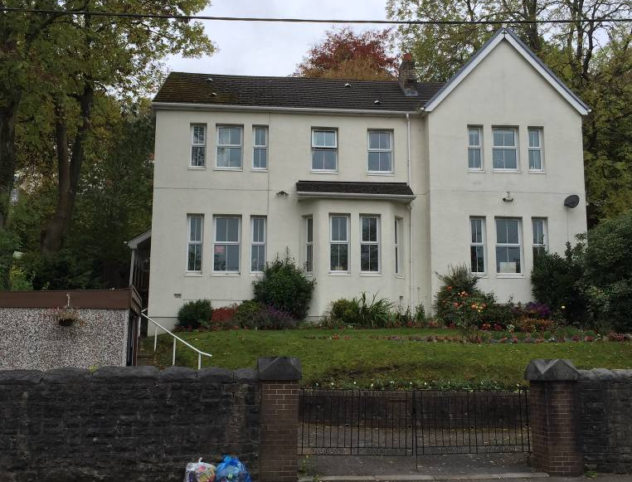

Address: Eureka Place, Ebbw Vale NP23 6PN
Style: Detached, two-storey house
Bedrooms: Five
Bathrooms: Two, one being en-suite
Kitchen: Fitted kitchen with adjacent pantry, separate utility room
Study: The study is a reception room within the main house
Date built: 1899
Listed: No, Conservation Area
Heating and hot water: Gas combi boiler, gas fire (after refurbishment)
EPC rating: C
Drainage: Mains
Garage: Detached, single, pre-fabricated style
Boundaries: Mixture of stone, timber and hedge
Grounds: Large, multi-level
Trees: Some large trees, protected within the Conservation Area
Drive/Parking spaces: Tarmacadam drive with one parking space

Comments: The house is large, with two staircases. It is a short walk from Christ Church and the main high street in Ebbw Vale. Leisure, educational and shopping facilities are available within and around the town.

Our Churches

The churches in our Ministry Area
have a range of different traditions

The Ebbw Valleys Group of Churches

Christ Church, Ebbw Vale

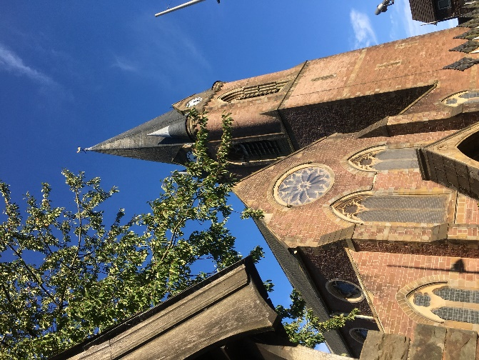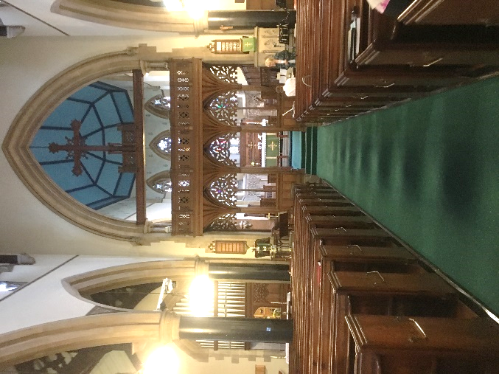

‘Middle of the road’ Anglican Church with regular Eucharistic services on Sunday’s and Thursday’s. Average attendance on Sundays ranges between 20 and 25; Thursdays are between 12 and 15. The Electoral Roll lists approximately 40.
Sunday services are sung Eucharists with a sermon – Red Book including a ministry of healing
Thursday services are said Eucharists with a homily – Green Book. We also hold a Midweek Bible study and Morning Prayer most weekdays.
Music is provided mostly with an electronic piano or electronic organ with a small music group. There is a full PA system with both a lapel microphone and static mics. Hearing loop system in place.
MISSION & OUTREACH
Children are a focal point for Christ Church; our outreach includes our Sunday school as well as connections to our local schools. We are proud that some of church members are school governors. We also strive to connect with our community through the local authority and community organisations; such as the Royal British Legion. Christ Church hosts frequent concerts by visiting musicians/choirs, acknowledging the quality of the building’s acoustics. Some of our other activities include our commitment to the Food Bank, Children’s Contact Centre, Street Pastors, Ladies Prayer Breakfast and visits to care homes and outreach to other churches via Churches Together. We also enjoy an active connection with the Highveld Diocese in South Africa.
We aspire to bring people closer to the love of God and to grow the Kingdom in this Ministry Area

CHURCH ORGANISATIONS
Christ Church has a well-organized Church Committee; as well as active churchwardens, treasurer and enthusiastic lay members. The church is financially secure; with tithing commitment (or working towards) by a number of church members.

CHURCH BUILDINGS
An iconic grand building about 150 years old, built in the style of Gothic Revival architecture with a spire; Christ Church is a Grade II Listed Building. Boasting seating for up to 450, major renovation works were undertaken 15 years ago. The renovation included upgraded electric wiring and modern central heating. There is also a toilet with DDA facility, two vestries and an Undercroft. We have an arrangement with the Ebbw Vale Male Choir for use of their hall for our gatherings/receptions in exchange for their use the church for concerts. Importantly, the peal of 8 bells is considered to be one of the finest in the UK.

LOCAL SERVICES, INFORMATION & POPULATION
Ebbw Vale developed in the 19th Century as a direct result of the Industrial Revolution; particularly coal mining and iron/steel making. The area is recovering from a period of high unemployment with local and national investment, and the current population is 18,500.
The Parish Church of Christ Church is located to the south of Ebbw Vale town in a prominent hillside position on the western side of the valley. The Church Street area is the oldest part of the town. Ebbw Vale town has a number of local businesses together with the larger supermarkets.
To the east of the Church in the base of the valley, occupying part of the old site of the steelworks, is a new 3 to 16 school (Ebbw Fawr Learning Community). There is also a Sixth Form College and a Leisure Centre close by. There are areas of the old steelworks site which are available for development for both housing and light industrial purposes. Inward investment by the local authority (Blaenau Gwent CB Council) and the Welsh Government is promised which should improve the employment prospects of the area. There is a railway station with a regular service to Cardiff. There are local bus services. There are 2 primary schools and a special needs school
Ebbw Vale benefits from being within a 15-minute drive of the Brecon Beacons National Park.

St David’s Church, Beaufort

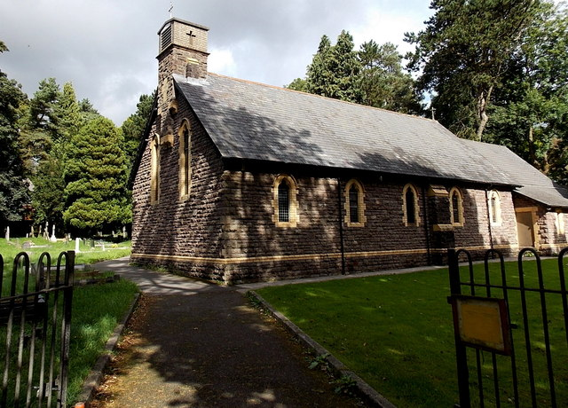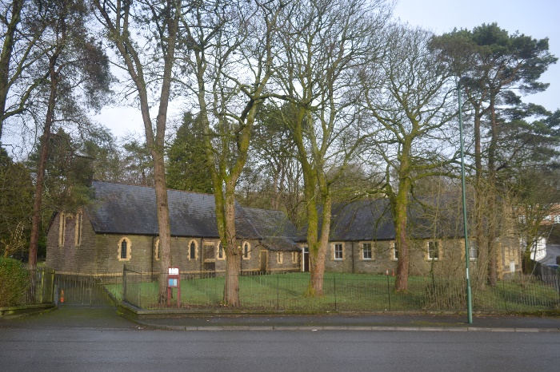

STYLE & PATTERN OF WORSHIP
Our weekly services on Sundays and Tuesdays are generally well attended. Home Communions are provided throughout the year. Some of our members are part of a prayer chain for anyone requesting prayer.
We hope to resume our monthly services at Bank House Residential Home. We are also interested in exploring Messy Church and Healing services.
We’re currently developing Welsh language worship with ecumenical partners.

MISSION & OUTREACH
The Hall serves as a strong link to the local community and is in regular use by both church and community groups. On a weekly basis it hosts two sessions of Parents and Toddlers; as well as a dedicated Kung Fu class. Additionally, the Hall is often hired for Baptism parties, birthday parties and or other one-off events.
Funerals, weddings and baptisms are also opportunities for the church to serve the local community. From January to November 2019, St David’s provided for 39 funerals, 4 weddings, 2 wedding blessings, and a baptism followed by a baptism party in the Hall.
We value our links with local schools. These links are maintained through assembly visits by the clergy, and the school visits to the church. Rhos-y-Fedwyn School and Glyncoed School both make regular visits; and Rhos-y-Fedwyn School celebrated their end of term with us. We were excited to hold a school Christingle service last year. A local Nursery (Buds to Blossoms) has also begun visiting the church.
Our congregation is also committed to raising funds for charitable causes. Notably, an Afternoon Tea was organised by a church member in aid of Velindre Hospital and over £1000 was raised. The local Food Bank is regularly supported; including a donation of goods received at our Harvest Thanksgiving.
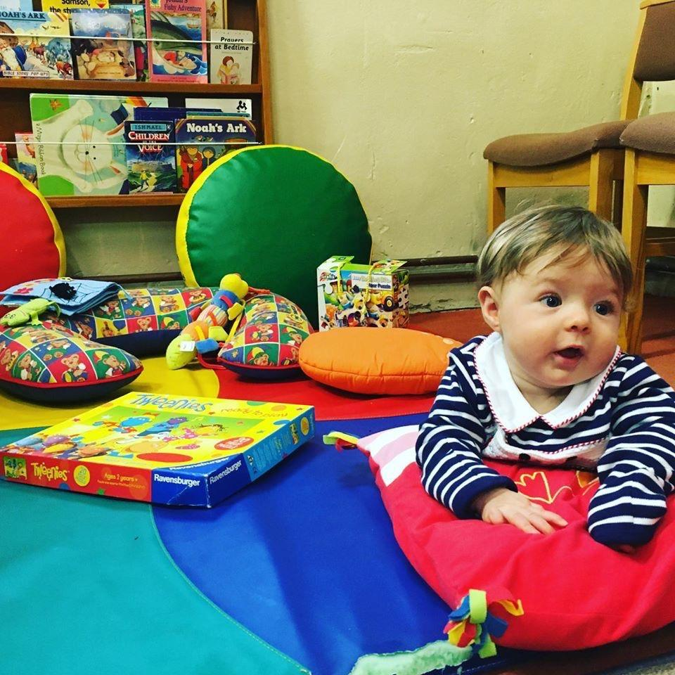

CHURCH BUILDINGS
The recent Quinquennial Inspection at St. David’s was carried out by the Diocesan Architect, Mr. Tim Pitt-Lewis. His report identifies and prioritises a programme of work to maintain the fabric of the building in good order. Our main priority is to carry out the proposed re-roofing work; due to be completed by early summer 2020.

LOCAL SERVICES, INFORMATION & POPULATION
With a population of approximately 3900, Beaufort is a suburb of Ebbw Vale. At the end of the 18th century, both Beaufort Iron Works and the Beaufort Male Voice Choir were established. While the iron works has since closed, the Male Voice Choir continues on today; making it one of the oldest in Wales.

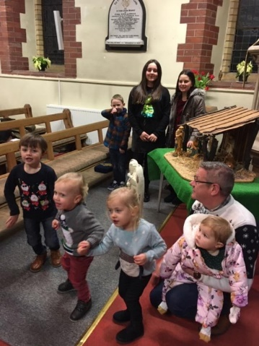
OUR ASPIRATIONS
Our aim is simply to welcome and engage with people in the community, and our prayerful hope is for church growth so that the Church remains at the heart of the community for future generations.

St Peter’s Church, Blaina

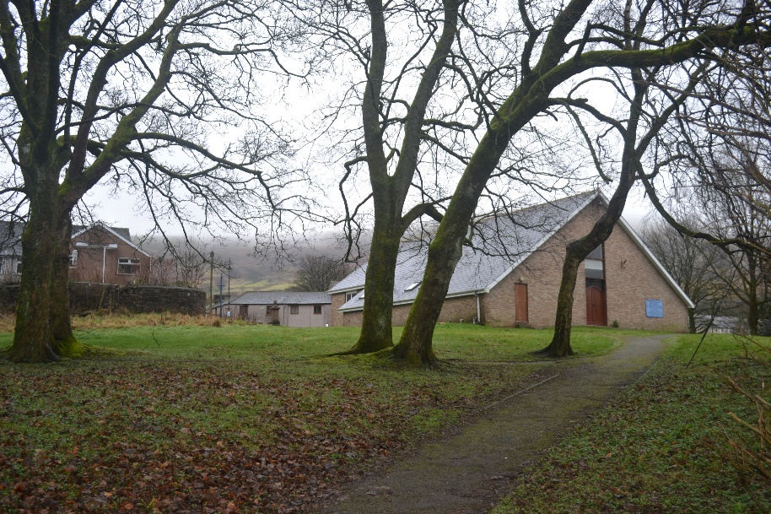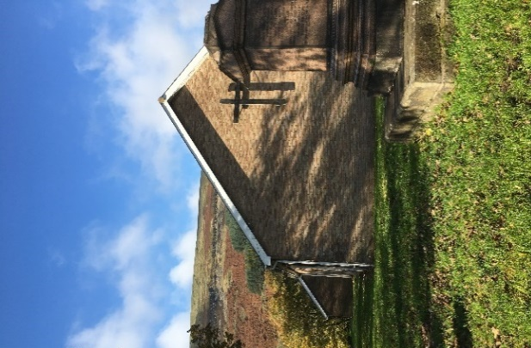
STYLE & PATTERN OF WORSHIP
There is a Eucharist every Sunday Morning at 11.00 am. This service uses CDs to accompany hymn singing and uses booklets for Holy Eucharist Liturgy, taken from the Red Book of Common Worship and Daily Prayer.
There is a mid-week Communion service at 11.30 – a said service using a combination of the Green Prayer Book for the readings and the booklets - Red prayer Book for the communion.

MISSION & OUTREACH
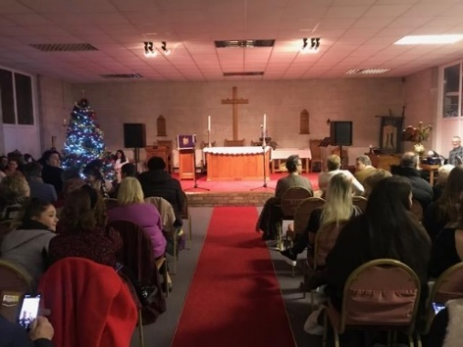
We engage in various fundraising and outreach activities; including several male voice choir concerts, concerts arranged by Katy Treharne through her connections to the West End, cream teas, auctions, exhibitions by the local Art Society, and a quiz night.
Once a month, St Peter’s holds a Christian meditation led by Revd. Tarie Carlyon.
During Holy Week St Peter’s and St Anne’s Nantyglo and three of the local Methodist Churches join together for services from Monday to Friday. Guest speakers are usually invited.
The Church has excellent links with the Nantyglo and Blaina Town Council.
The church is used every Saturday Morning by the Academy of Vocal Arts. This group put on a Christmas Celebration Concert in the Church which was very well attended.

CHURCH BUILDINGS
The current St. Peters was consecrated in 1974 and replaced the previous church which was built in 1857 and demolished in 1968. However, it is believed that a church has existed on the site since somewhere between 1495 and 1505.
St Peter’s Church is a modern brick building with slate roofs situated in the centre of Blaina, adjacent to the High Street. The church is not a listed building. It is set to the South of its large churchyard. The former burial ground surrounds the church and grass cutting is undertaken by the local authority. The churchyard is no longer open.
There is a hearing loop system, and sound reinforced system in the church. The church has an organ and an electric piano. Seating comprises of modern oak chairs with padded cushions.
The modern design of the church serves the parish very well and is well maintained. The church comprises a sanctuary, a nave, a vestry, a meeting room, an office, toilets, and a fully equipped kitchen. The building is capable of being divided by a folding screen to separate the area of worship from the multi-purpose Hall. We are proud that our church is able to be a modern and flexible community space.

LOCAL SERVICES, INFORMATION & POPULATION
Blaina has a population of approximately 4800. There are lots of local services and clubs including
Integrated Children’s Centre, The Local Library, Blaina Institute, Bowls Club, Cricket Club, Rugby Teams, Air Cadets, Scouts, Keep Fit classes in the Community Centre, An Archaeological Group, A history Group

Primary Schools:
- Ystruth Primary
- Coed y Garn Primary
- Ysgol Gymraeg Bro Helyg Primary.

Comprehensive Schools:
- Brynmawr Comprehensive School
- Abertillery Comprehensive School.

The Welsh medium Comprehensive is Ysgol Gyfun Gwynllyw in Pontypool.

OUR ASPIRATIONS
Our aim is to keep our church open and welcoming to serve and be part of the community.

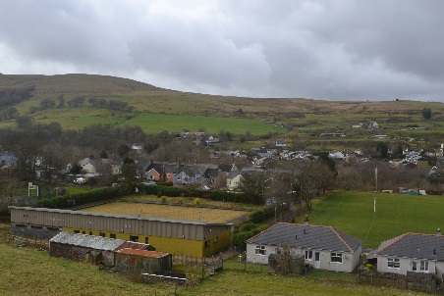
Holy Trinity and St Anne, Nantyglo

STYLE & PATTERN OF WORSHIP
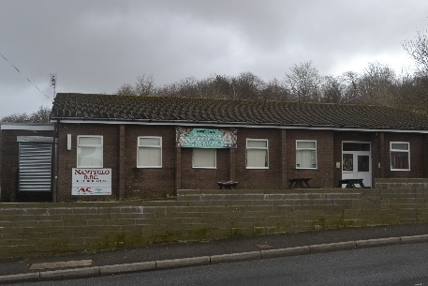
There is a Communion service every Sunday Evening at 5.00 pm. This service uses CD’s to accompany hymn singing and uses booklets for Holy Eucharist Liturgy, taken from the Red Book of Common Worship and Daily Prayer.

MISSION & OUTREACH
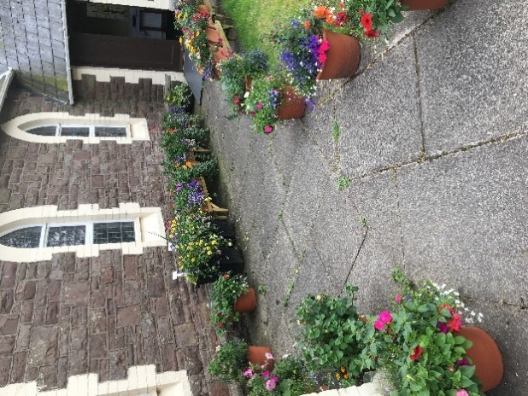
We enjoy hosting a variety of fundraising and outreach activities; including a monthly tea and toast morning, a Macmillan coffee morning, auctions and raffles, choir concerts, sponsored walks, various sales, and a foodbank drive.
We also engage in school assemblies, an annual Harvest supper, and an open day on our Patronal Saint’s day.
There is also a beautiful memorial garden set up in the church grounds for anyone who wishes to remember a loved one.
We enjoy good connections with the local Methodist Churches and join with them to hold Lent and Holy Week services.

CHURCH BUILDINGS
Holy Trinity and St. Anne’s Church dates from 1844. It comprises of a chancel, a nave, a priest’s vestry, and an organ chamber. There is a modern Sanctuary extension to the East end of the Church. At the West end of the Nave are stairs down to a toilet, storage, and a fully equipped kitchen. A stair lift has been installed for people with disabilities to use the facilities.
The church has a hearing loop system, and a sound reinforcement system installed. The church has an electric organ and modern oak chairs with padded cushions.
The church itself is set within the community of 4000. The church does not contain any existing burials and the churchyard is not a designated burial ground. The grounds are maintained by the church and the church is not a listed building.

OUR ASPIRATIONS
The creation of a successful messy church/young people's group
Mother's union/women's group
Regular bible study/Anglican exploration courses
Joint Benefice services for special occasions
Drop-in social groups such as craft/sit and chat (bereavement/lonely)/advice - sign posting to appropriate agencies
To be relevant and welcoming and inclusive Church.
To reach out to those people who no longer attend church
To grow in our faith

St Paul’s Church, Cwm

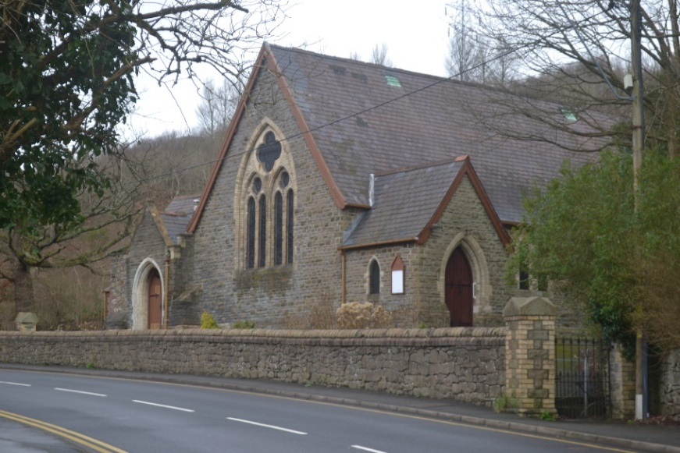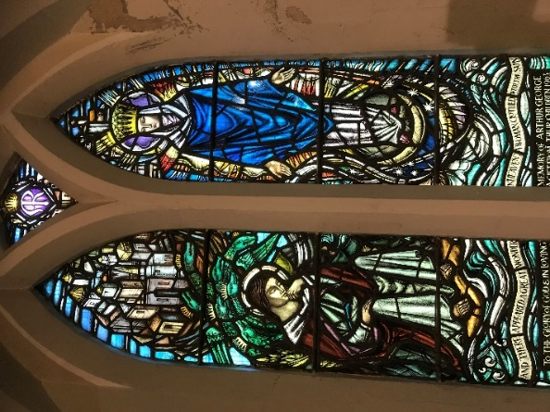

At present St Paul’s, Cwm is moving towards redundancy and the congregation is exploring where they will be worshipping within the local community.
“We are committed to keeping a worshipping community at the heart of Cwm. We are sorry to be losing our well-loved building, but excited at the possibilities for new ministry and mission in our community.”

STYLE & PATTERN OF WORSHIP
Sunday 10.30am Eucharist Red Book
Wednesday 10.30am. Eucharist Green Book followed by coffee
MISSION & OUTREACH
- The Crib Service held on Christmas Eve is well supported by the community
- We intend to hold a Christmas Carol Service this year
- We are part of the Cwm Council of Churches. We hold monthly evening services on a rota system
- We have several members of the local churches join us for our mid-week Eucharist Service
- The local pubs and clubs support the church providing boxes for customers to donate their loose change
- Fundraising: In the past we have held concerts and Auctions. We have a monthly pound club draw.

We have a small, ageing congregation with no young people or children attending.
We are a loving congregation and we would like our church to grow and be central to the life of the community in Cwm.

Blaenavon Group of Churches
Our new Ministry Area is made up of churches in a range of traditions and styles.
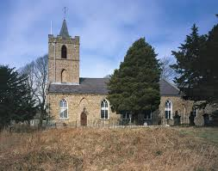
St Peter’s Blaenavon
St Peter's is a large town church with very interesting architecture being furnished mainly with products from the local iron works being built in the 1800's where cast iron was the new building material and even has a cast-iron font dated 1805. It is built in a non-conformist style with a large balcony but is a traditional Anglican church which holds regular Sunday services using the 1984 rite plus a midweek, said Eucharist.
Prior to COVID weekly Sunday worshippers were in the region of 30-40. Those numbers are now reduced but slowly growing. Midweek service attendance are around double figures. The church has a 5-acre graveyard with over 40,000 graves but is now closed and for funerals and much use is made of the local council run cemetery at Varteg Hill about 2 minutes' drive from the town.
The church is well-equipped with an excellent sound system, an excellent pipe organ as well as an electronic piano/organ, a good heating system and has a toilet and is well placed for large community services being located opposite the cenotaph which impacts on the church as there is a strong British Legion Branch in the town.
The Parish Office (for Blaenavon) is also located at St Peter's and holds many records from earlier churches and burial grounds now closed.

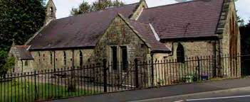
St Paul’s Blaenavon
St Paul's is much smaller and styled along the lines of an Oxford movement church with a central aisle and a Lady chapel which boasts an altar stone from the original late mediaeval church at Capel Newydd, the original settlement before Blaenavon itself was born!
St Paul's has a small pipe organ and has a Priest's vestry plus a choir vestry.
Regular Sunday service are held here plus a midweek Eucharist service in the evening. All services use, at the moment, the 2004 rite but worship is very Anglo-Catholic following a tradition of the church for many years. Incense is used and the service is mainly sung where appropriate. It has a good heating system and a good sound system recently installed. There is a toilet across the road in the lower ground floor of the hall. There is a potential for construction of a kitchen area which is on-going in its concept.
St Paul's is very much the community church and is going through a phase of integration with the Blaenavon Heritage V C Primary school with about 500 pupils but this, again, is a recent work and on-going. It is anticipated that regular assemblies will be held in church with the children walking some 150 yards to church plus regular church/school services in conjunction with the school.
Again, prior to COVID numbers were well into the 20's for Sunday worship but have dropped to low double figures but it is hoped that increased activity through the school and the local residential home will begin to brings worshippers back to church as well and encouraging a new generation of regular worshippers.
The area around Blaenavon is a mix of old industrial buildings plus some breath-taking views over the Usk valley, the Keeper's Pond and Foxhunters Grave. It is located on the edge of the Brecon Beacons and has limitless walks for both strollers and serious walkers. There are some lakes providing fishing for the enthusiast, an excellent library and Heritage centre and a fantastic Workman's Hall, recently refurbish which also includes a small cinema. The potential for growth is amazing and very vibrant.
The parish has a good record of working with other churches in the area especially the Independent Pentecostal church in Blaenavon and another in Abersychan.

Local facilities and activities
Blaenavon sits high in the eastern valley hills with a population of about 6,500 and the parish extends to accommodate Talywaun, Garndiffaith and Varteg serving about 9-10,000 people.
From its elevated position the town has good access to the agricultural side of the counties with Abergavenny being a short drive away. Westwards is Brynmawr a good-sized shopping centre and, south of the county lies Pontypool and Cwmbran with the main university city of Newport being some 1/2 hour away by car but with direct bus links to all three districts.
Abergavenny provides good rail links north and south and Newport east and west.
Blaenavon is part of the World Heritage Foundation and is a World Heritage town with much recent industrial history and is a major tourist attraction.

Abertillery Group of Churches
The congregations of these churches are small and have been on a downwards path for the last 15 years. The postholder will need to be aware of the isolation in the community although there is good support from the diocese and from Church Army. Whilst there is much work to do there is a feeling of real hope with the new energy being brought by the Gwent Valley Centre of Mission.

St Michael’s, Abertillery has an excellent physical position, being on the High Street in the heart of the community. The small Thursday market is held next door to the church, where there are also bus stops and a taxi rank.
St Paul’s, Cwmtillery is a Victorian Church built on the edge of Cwmtillery overlooking the Cwmtillery Lakes. It has a centrally sited well equipped church hall.
St John’s, Six Bells is an accessible combined church and community hall style building, built in the 1960s.
St Mark’s, Llanhilleth is an early 20th century building on two levels with an accessible well-equipped hall sited below the worship area.

Local facilities and activities
There is a local Tesco and a small Thursday market, though the High Street is in decline. There is a small local museum, a library and a sports centre in the area, as well as The Guardian Miner Statue and Park and Cwmtillery Lakes Country Park.

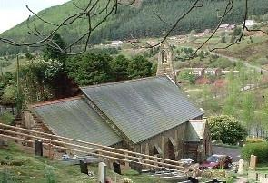

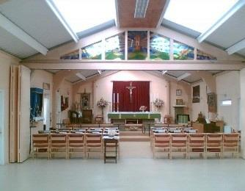
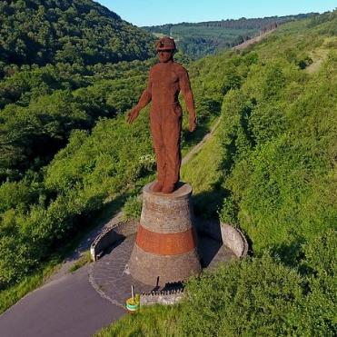

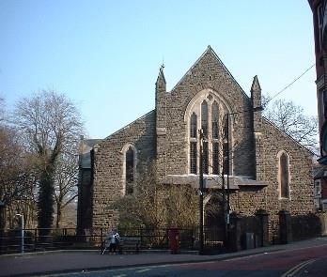

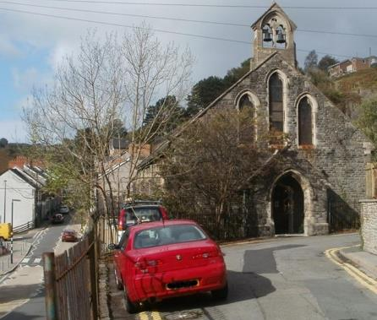

Gwent Valley Centre of Mission
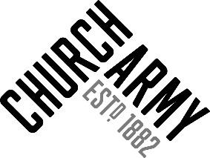
A previous Bishop of Monmouth, Rowan Williams, wrote “Mission is finding out what God is doing and joining in”. And this is at the heart of the new Gwent Valley Centre of Mission.
The Diocese of Monmouth is delighted to be in partnership with the Church Army in creating the Gwent Valley Centre of Mission.
As a Diocese we are committed to encouraging and enabling mission to flourish in all its diversity, and the Centre of Mission is an important part of this commitment. We aspire that learning together in mission will lead us to discover and share in God’s amazing plans for this area and in so doing establish new examples of Christian discipleship and worship at the heart of the Upper Valleys Ministry Area.
We believe the Centre of Mission will bring fresh hope to the local communities, many of which face issues of multiple deprivation. It will pioneer new expressions of Christian community amongst the people of Abertillery, Six Bells, Cwmtillery, Llanhilleth and the surrounding communities in the Upper Valleys. Together we are aiming to proclaim the love of God for all people in an open, generous and life affirming way, celebrating compassion, kindness and mutual respect for everyone.
Hannah Seal, the Lead Evangelist, has already done some great work and we are very pleased to have appointed new Pioneer Evangelist to join her and us in this exciting venture.
St Paul wrote in Romans 15:20 “I have made it my ambition to preach the gospel where Christ is not yet known.” This partnership, this Diocese, this Centre of Mission aspires to do just that, make Christ known so that more and more people will experience his love.
The Centre of Mission will bring fresh hope to the community. It will pioneer new ways of establishing Christian community amongst the people of Abertillery. It will focus on the existing building of St Michaels which is situated in the heart of the community in a prominent position.

ThispartnershipwillestablishtheCOM atStMichael’sChurch, Abertillery developing the building as a new and innovative hub for evangelism and community engagement.
Our
Church Schools
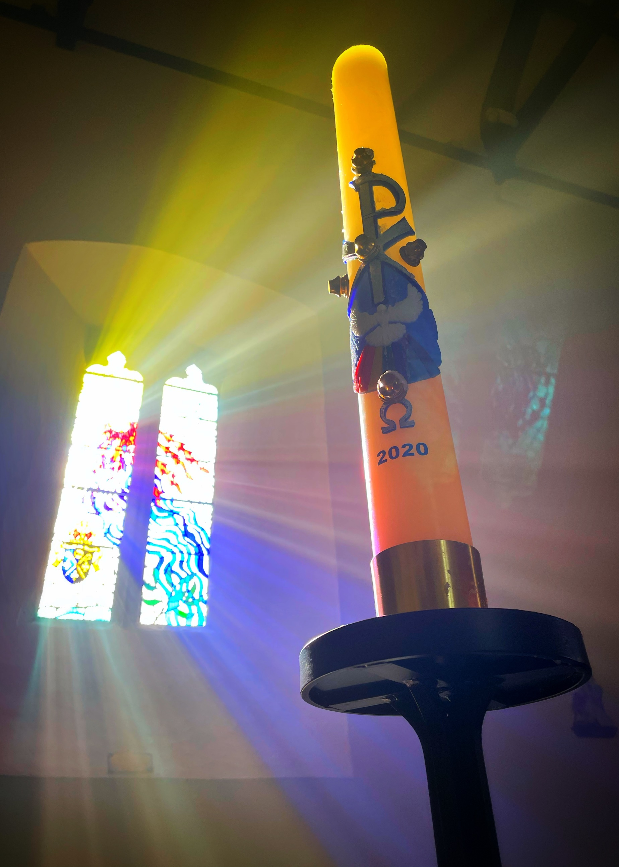

Our Emerging Mission and Values

Drawing on the experiences gained across the diocese, here are some aspects of our emerging mission which we feel will be important to us as the Ministry Area continues to take shape:

Collaboration

We are keen to make the most of all the new opportunities to collaborate and co-ordinate together. We want to encourage our church to “cooperate to offer the best worship” by “supporting one another and sharing our resources for greatest impact” and “forming strong and focused teams across the Ministry Area.”

Facing Challenges Together

We are both realistic about the challenges ahead and hopeful for the future. In ten years’ time, when we look back, we want to be able to say that “we faced up to the challenges of the future instead of ignoring them”, “we respected differing opinions” and “we embraced change with optimism and enthusiasm”. This will require us to “be mindful of people’s fears”, so we can “involve and inform” and “act with transparency” at each step of the way.

Community and Kingdom Oriented

This is also an opportunity for us to renew our commitment to be a compassionate and faithful presence in our local communities. With this in mind, we aspire to prioritise “outreach and service to the poor” so that “we are visible, we are seen, we are present in our communities.”

#
#
#
Should you wish to have an informal discussion aboutf the posts, please contact:
The Ven Ian Rees
Archdeacon of Monmouth
Tel. 07983 684151
Archdeacon.monmouth@churchinwales.org.uk

Diolch!
Thank you for considering joining the team.
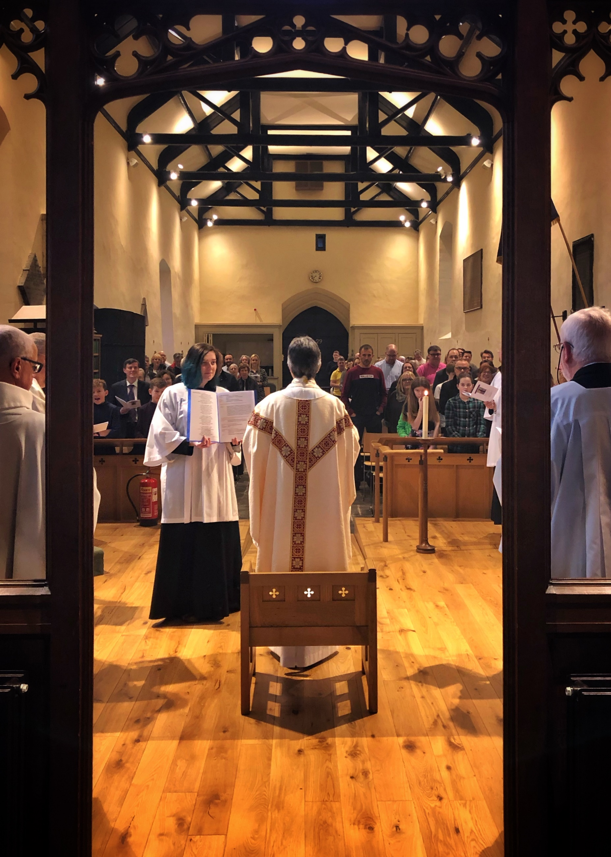

Diocese of Monmouth
The Church in Wales

