

GOVERNING BODY MEETING

**19 & 20 April 2023**

**QUESTION TIME**

**1. Mrs Hannah Wilkinson (diocese of St Davids)**

How many of the clergy regularly use their church in Wales email address?

**Answer to be given by Mr Mike Wakeman, Director of IT**

A request was made by the Diocesan Secretaries to the RB’s IT Department in 2020 to provide email addresses to all clergy. This was possible to deliver at no cost to the dioceses because of the way that the Office 365 software licenses are provided by the RB. A list of clergy was provided by each Diocese and an Office 365 account, including a Church in Wales address was made available to every cleric on those lists. The IT Department notified each cleric of the existence of the new account and provided access details. In addition, helpdesk services were made available to clergy to provide support for log-in issues or usage problems.

The IT Department is part of the RB and has no mandate to compel usage of the new accounts. As such, each diocese and Bishop were free to determine how they wanted their clergy to use the new accounts. Some requested that clergy used the addresses as their professional point of contact, others were content to let clergy do so on a voluntary basis. Usage therefore varies quite markedly across dioceses, as you can see in the table that is displayed behind me.

The first column of the table shows the number of accounts that were created in each diocese. The second column shows usage over a 30 day period prior to 12th April 2023. The figure in brackets provides a percentage of the total active accounts that were used in that timeframe. The final two columns show the volume of traffic received and sent by the active accounts, regardless of whether the owner accessed them or not.

If you aggregate the percentages, the top line figure is that 41% of Church in Wales email accounts that have been provided to clergy have been used within a 30 day period prior to April 12th 2023. 59% were inactive during that same period.

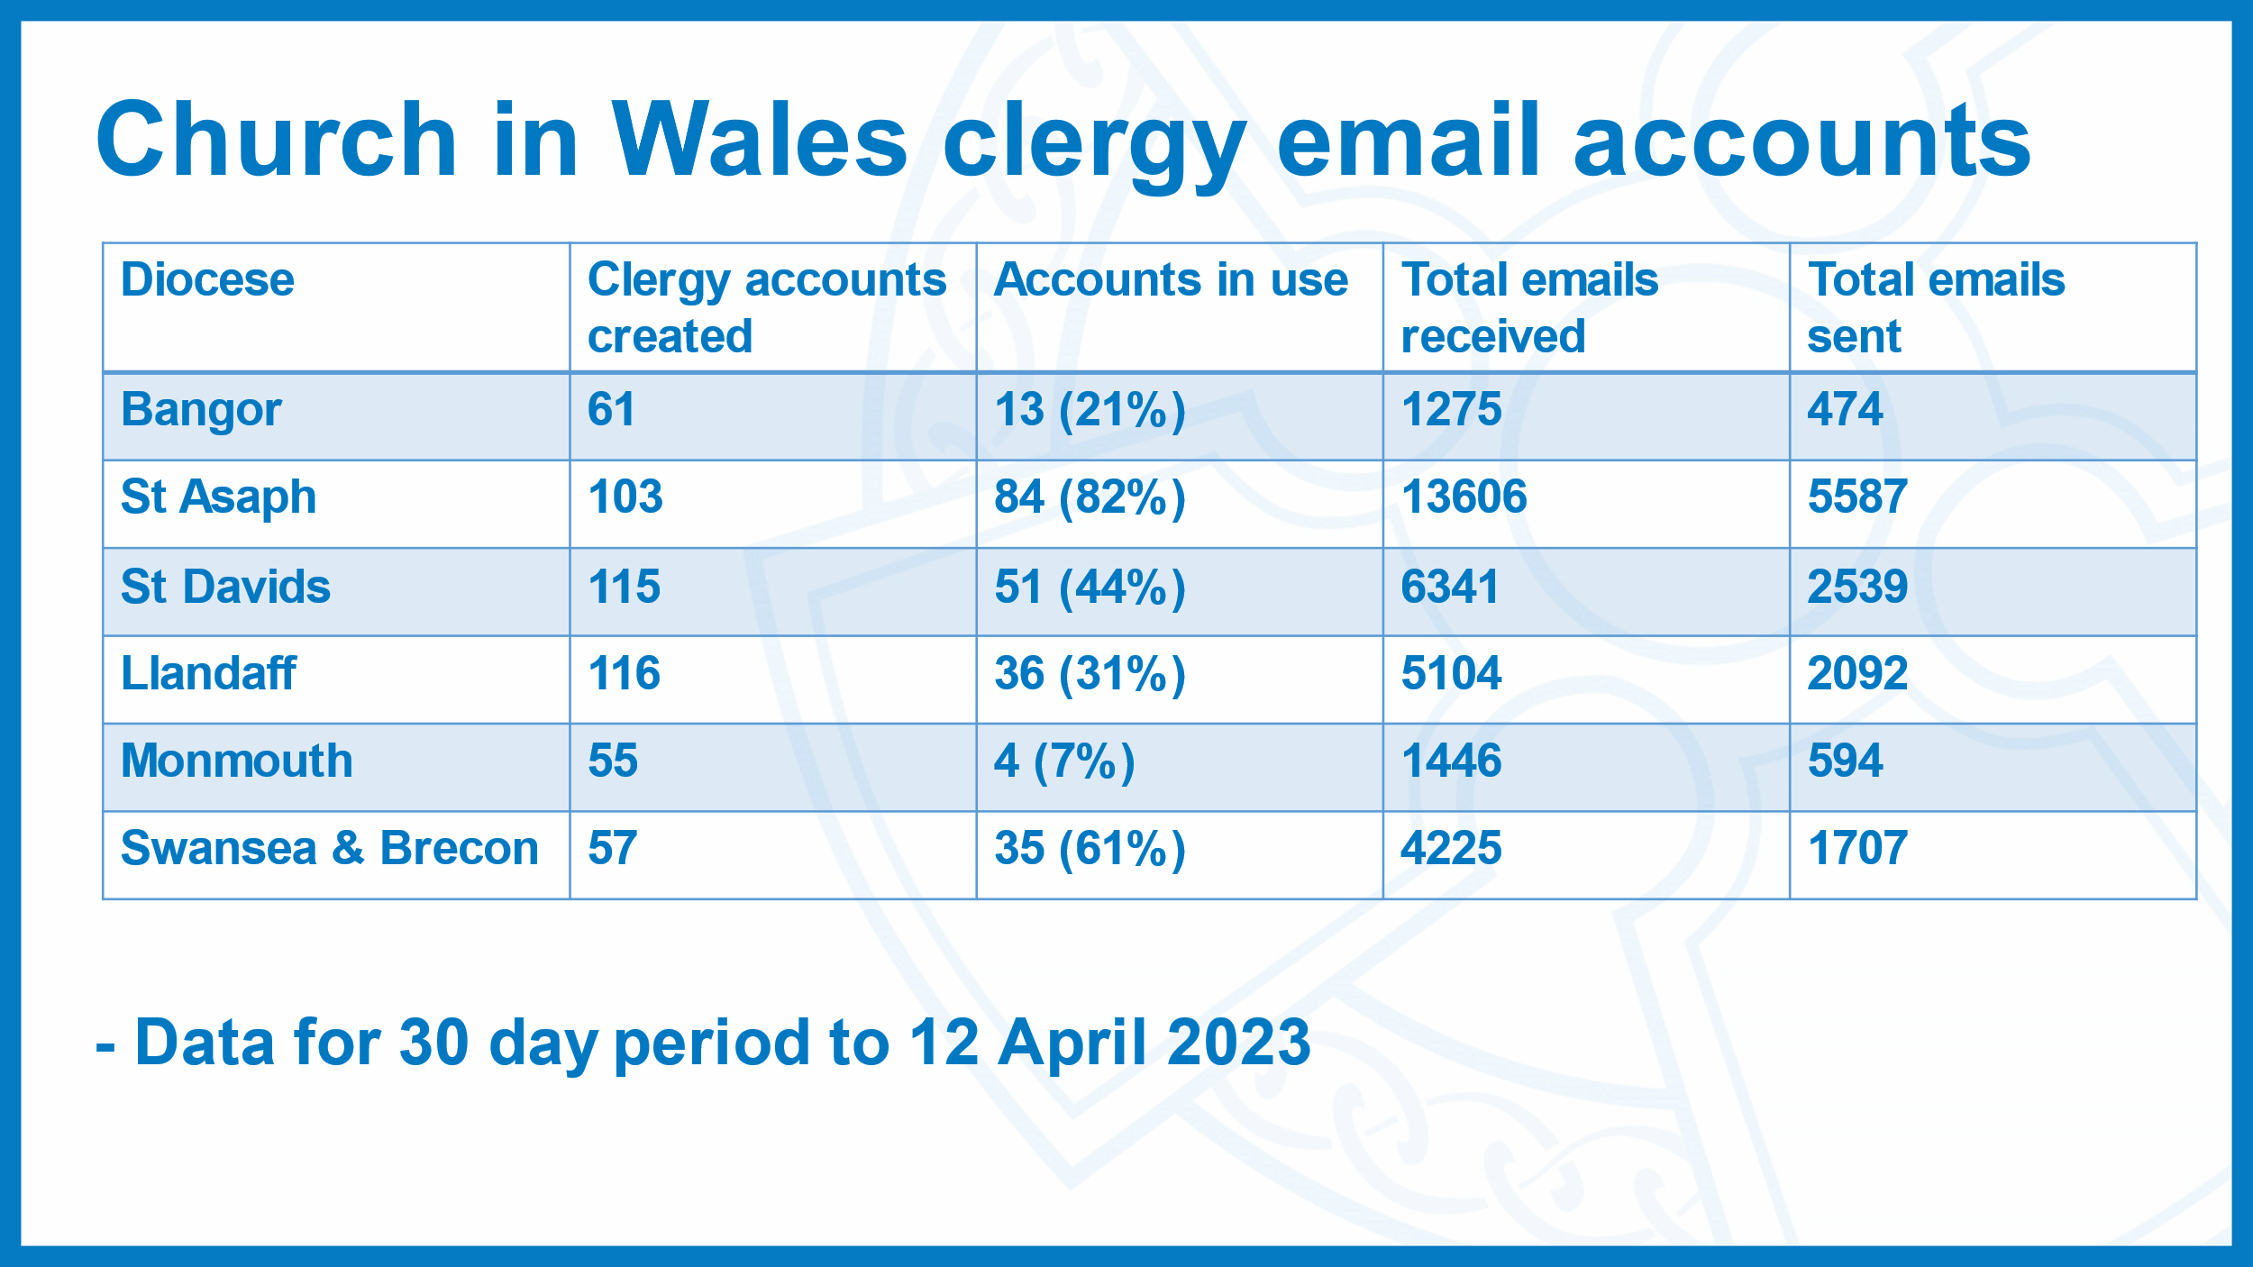

**2. The Reverend Dr Jonathon Wright (diocese of Swansea & Brecon)**

The responsibility for sending a candidate to train for ordination rests with the diocesan Bishop.  As part of the selection process, a candidate attends a Provincial Selection Conference.  A Provincial Selection Conference can either recommend that the candidate is suitable for training, not yet ready for training, or is not suitable for training.  For the years 2013-2017 and 2018-2022 years, how many candidates have the bishops sent to commence training for ordination and how many of those were not recommended to begin training to by the Provincial Selection Conference?

**Answer to be given by the Bishop of Monmouth**

Thank you Jonathon for this interesting question. I shall begin my answer by first outlining the process that candidates go through at Provincial Discernment Panels.

When candidates attend a Provincial Discernment Panel, they are graded by each of the Discerners, with whom they meet individually, and the Chair of the Discernment Panel with a grade between A to D. These individual grades are then collated and moderated by the Provincial Discernment Panel to produce a final overall grade for each candidate, again ranging from A to D.  An overall grade of either an A or B indicates that the candidate either meets all of the discernment criteria, or the vast majority of the criteria and that the recommendation of the Panel is that the candidate go forward for training. An overall grade of a C or D indicates that the candidate does not meet the discernment criteria, and the recommendation of the Panel is that the candidate does not go forward for training.

However, the nature of the discernment process means that a candidate who was not recommended for training would be unlikely to receive this recommendation without a degree of nuance. Many candidates who are not recommended for training by the Panel, are deemed to have a discernible vocation, but at the time of discernment were not deemed to sufficiently meet the criteria, possibly due to lack of experience or personal circumstances. In these cases, the Panel will note in the reports that are prepared for the Bishops that such candidates could return to a future panel after a time of appropriate reflection, preparation and demonstrable commitment to exploring their sense of calling. Equally, many candidates who are not recommended for training by the Panel are not deemed to meet the criteria for ordained ministry, but might be thought to display the required qualities for another calling, for example as authorised Lay Ministers.

Once the Panel have discerned their recommendations for each candidate and the reports have been prepared, it is then up to each of the diocesan Bishop concerned to further discern what the next step will be for each candidate. The Provincial Discernment Panel has always acted in a purely advisory capacity and Bishops may at their discretion accept or reject the Panel’s recommendations. In some cases this has resulted in candidates who have not been recommended by the Panel going forward for training. As this final decision rests with the individual Bishops, records are not kept by either the Chair or the Coordinator to the Provincial Discernment Panels about how many candidates who were not recommended, go on for further training and discernment at the St Padarn’s Institute.  Anecdotally, we are aware of cases in recent years where candidates have been put forward for training against the recommendations of the Panel. However, the lack of provincial records of these decisions, the movement and retirement of bishops, the change from St Michael’s College to the St Padarn’s Institute and necessary precautions to not risk potentially identifying individuals concerned means that we are unable to give a concrete figure for the timeframe of the question.

With regards to the total numbers of candidates who have been recommended to go forward for training by the Provincial Discernment Panel, in the years 2013 to 2022, of the 187 candidates who were presented at panel, 141 were recommended for training.

**3. Ms Susan Fogarty (diocese of Bangor)**

The Bench of Bishops in their Explanatory Memorandum to the September 2021 Bill, described Governing Body authorising blessings for same-sex couples as *‘a step on the way towards repentance of a history in the Church which has demonised and persecuted gay and lesbian people, forcing them into fear, dishonesty and sometimes even hypocrisy, and which has precluded them from living publicly and honestly lives of committed partnership.’*

How does the Representative Body ensure that funds expended by the Evangelism Fund are being spent only on projects which embody and promote the Church in Wales’ clearly-stated position on inclusion and diversity, in particular with reference to Hope Street, Wrexham and Citizen Church, Cardiff (which are both members of a network of churches associated with Holy Trinity Brompton in London)?

**Answer to be given by the Archbishop**

The Church in Wales voted at the meeting of the Governing Body in September 2021 to authorise the blessing of same sex relationships following civil arrangements. This was a further step towards the inclusion described in this question and followed an earlier provision of prayers authorized by the Bench in April 2016 for same sex couples. We ought to note that for many LGBTQI+ Christians, this was too little and too late. For other Christians it was too much and too soon. We should be therefore cautious when asserting the Church in Wales has a clearly stated position on inclusion and diversity.

Those who worship in the Church in Wales take a range of views on issues of human sexuality and the bishops have not sought to impose uniformity in this area. Christians often develop in their understanding of human relationships. What facilitates serious engagement is respectful conversation and the freedom to disagree well. These are critical conditions which allow people to develop and change their views or even, retain their convictions respectfully.

The Representative Body is committed to working with the bishops towards a Church in Wales which is well-resourced to make new disciples, who grow in their faith, across the whole range of church traditions. Each diocese, when looking to establish new ministries or provide new resources for existing ones, takes proper regard of the ethos and understanding of any organisation with whom we might work. This includes the Church Revitalisation Trust who work to establish church plants in the UK.