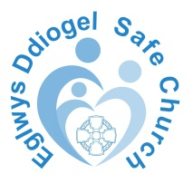
Form I
Declaration of Safeguarding Procedures

PCC Name / Ministry Area / Mission Area*

Name:

Role:

I (insert full name)
hereby declare that I have seen and understood the procedures on how to deal with concerns and allegations regarding safeguarding and will comply with the Church in Wales Safeguarding Policy.

Signature |  | Date:

The Safeguarding Policy (see Section 1) should be signed and displayed in a public place in your church or church hall

* Ministry / Mission Area name only to be used in united and merged Parishes.

